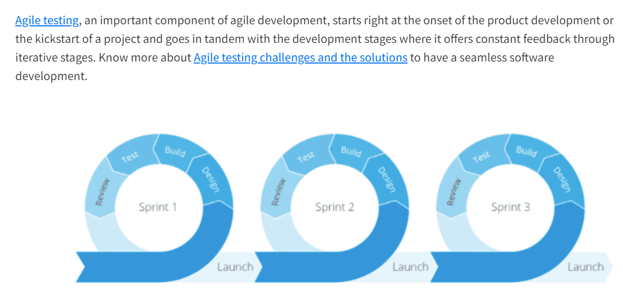

# Command line Basics

Change Directory, directory list, present working directory

Windows – cd & dir

Macos/Linux – pwd & ls & cd & clear

One requirement for each deployment.

To any concept or terms just use w’s what, why and where, How,

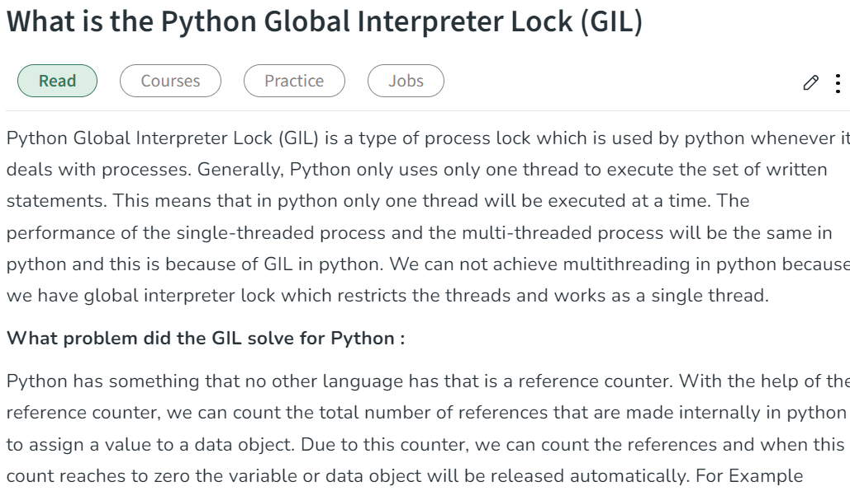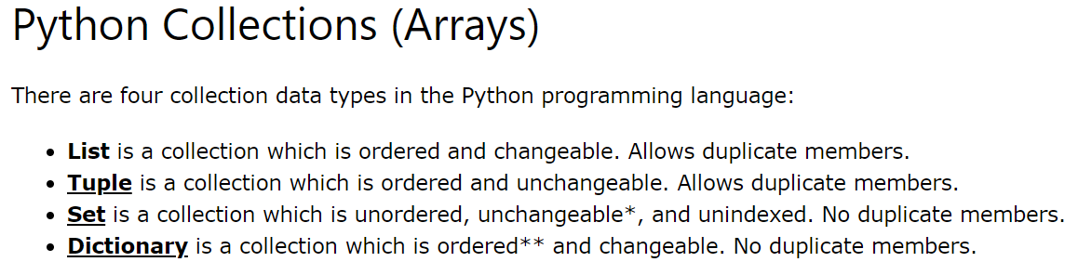

**List** and **Tuple** are the collection data types, both data types are used to store the more items/collection of items in single variable. **List** offers storing, updating, removing, and retrieving element from the collection. Where **Tuple** just offers storing and retrieving the items because tuple is unchangeable.

**Actuators and Generators:**

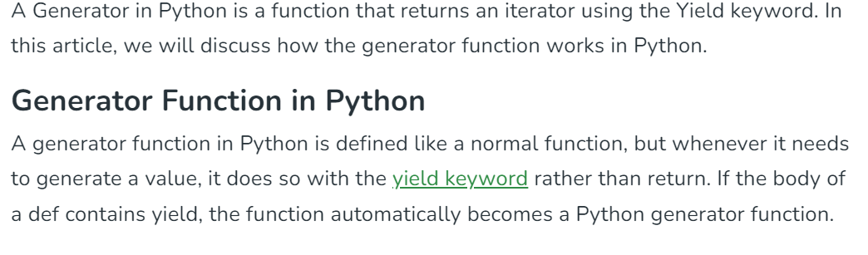

Python Generator functions return a generator object that is iterable, i.e., can be used as an [Iterator](https://www.geeksforgeeks.org/iterators-in-python/). Generator objects are used either by calling the next method of the generator object or using the generator object in a “for in” loop. We can simply retrieve [next() function](https://www.geeksforgeeks.org/python-next-method/).

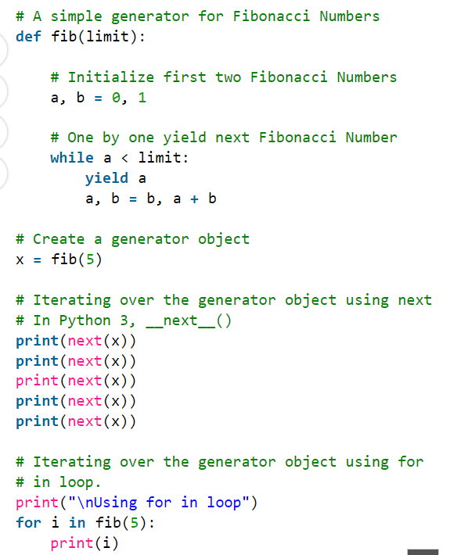

Actuator endpoints help us monitor our services. By using actuators, we can gain a lot of information about what’s going on.

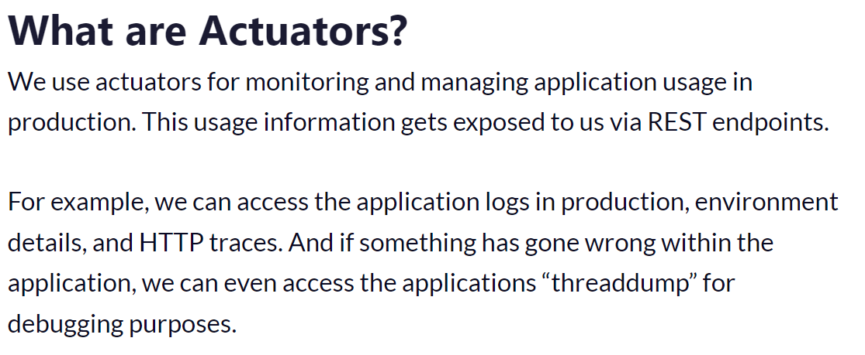

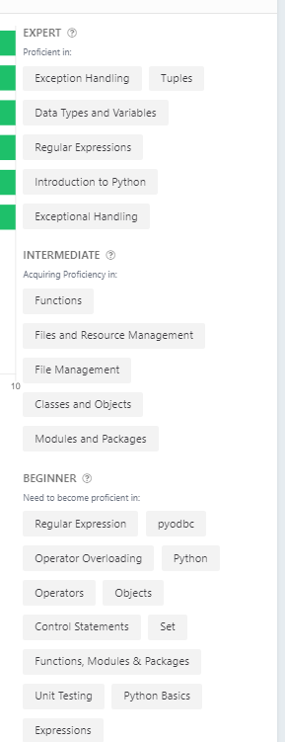

# **Foundational Concepts:**

* **Core Syntax and Data Types:** Mastering variables, operators, control flow (if/else, loops), functions, data structures (lists, tuples, dictionaries, sets), and string manipulation.
* **Object-Oriented Programming (OOP):** Understanding classes, objects, inheritance, polymorphism, encapsulation, and how to structure well-designed classes.
* **Functional Programming (FP):** Familiarity with pure functions, immutability, higher-order functions (map, filter, reduce), and their potential applications.
* **Exception Handling:** Knowing how to handle exceptions (errors) using try/except blocks and custom exceptions for robust code.
* **Standard Library:** Having a good understanding of commonly used modules like os, sys, json, datetime, math, and others for various tasks.
* **Version Control:** Proficiency in using Git for version control, branching, merging, and collaborating on code projects.
* **Testing:** Ability to write unit tests (testing individual functions) and integration tests (testing how components interact) using frameworks like unittest or pytest to ensure code quality.

**Intermediate and Advanced Concepts:**

* **Decorators:** Understanding how decorators can modify the behavior of functions and classes, leading to cleaner and more reusable code.
* **Generators:** Creating generators for efficient memory usage when dealing with large datasets or infinite sequences.
* **Context Managers (with statement):** Using with statements to simplify resource management (e.g., automatically closing files).
* **Iterators and Iterables:** Knowing the difference between iterators and iterables, and how to create custom iterators for custom data structures.
* **Asynchronous Programming:** Understanding concepts like coroutines and asynchronous I/O using libraries like asyncio for non-blocking operations.
* **Regular Expressions:** Learning to use regular expressions for complex text pattern matching and manipulation.
* **Metaprogramming:** Exploring metaprogramming techniques for advanced code manipulation, though this is less commonly used.

**Beyond Syntax:**

* **Problem-Solving and Algorithmic Thinking:** Being able to break down problems into smaller, solvable steps, choose appropriate algorithms and data structures, and analyze code complexity.
* **Object-Oriented Design (OOD) Principles:** Understanding design patterns, SOLID principles (Single Responsibility, Open/Closed, Liskov Substitution, Interface Segregation, Dependency Inversion), and best practices for designing robust and maintainable object-oriented systems.
* **Design Patterns:** Familiarity with common design patterns like Factory Method, Singleton, Adapter, Observer, and their use cases.
* **Testing Strategies:** Writing different types of tests (unit, integration, end-to-end) to cover various aspects of your code.
* **Error Handling and Debugging:** Effectively handling exceptions, debugging complex issues using print statements, debuggers, and logging techniques.
* **Performance Optimization:** Understanding how to optimize code for speed and memory efficiency, using profiling tools to identify bottlenecks, and applying optimization techniques like caching.

# Introduction

**Foundational Concepts:**

* **Core Syntax and Data Types:** Mastering variables, operators, control flow (if/else, loops), functions, data structures (lists, tuples, dictionaries, sets), and string manipulation.
* **Object-Oriented Programming (OOP):** Understanding classes, objects, inheritance, polymorphism, encapsulation, and how to structure well-designed classes.
* **Functional Programming (FP):** Familiarity with pure functions, immutability, higher-order functions (map, filter, reduce), and their potential applications.
* **Exception Handling:** Knowing how to handle exceptions (errors) using try/except blocks and custom exceptions for robust code.
* **Standard Library:** Having a good understanding of commonly used modules like os, sys, json, datetime, math, and others for various tasks.
* **Version Control:** Proficiency in using Git for version control, branching, merging, and collaborating on code projects.
* **Testing:** Ability to write unit tests (testing individual functions) and integration tests (testing how components interact) using frameworks like unittest or pytest to ensure code quality.

**Intermediate and Advanced Concepts:**

* **Decorators:** Understanding how decorators can modify the behavior of functions and classes, leading to cleaner and more reusable code.
* **Generators:** Creating generators for efficient memory usage when dealing with large datasets or infinite sequences.
* **Context Managers (with statement):** Using with statements to simplify resource management (e.g., automatically closing files).
* **Iterators and Iterables:** Knowing the difference between iterators and iterables, and how to create custom iterators for custom data structures.
* **Asynchronous Programming:** Understanding concepts like coroutines and asynchronous I/O using libraries like asyncio for non-blocking operations.
* **Regular Expressions:** Learning to use regular expressions for complex text pattern matching and manipulation.
* **Metaprogramming:** Exploring metaprogramming techniques for advanced code manipulation, though this is less commonly used.

**Beyond Syntax:**

* **Problem-Solving and Algorithmic Thinking:** Being able to break down problems into smaller, solvable steps, choose appropriate algorithms and data structures, and analyze code complexity.
* **Object-Oriented Design (OOD) Principles:** Understanding design patterns, SOLID principles (Single Responsibility, Open/Closed, Liskov Substitution, Interface Segregation, Dependency Inversion), and best practices for designing robust and maintainable object-oriented systems.
* **Design Patterns:** Familiarity with common design patterns like Factory Method, Singleton, Adapter, Observer, and their use cases.
* **Testing Strategies:** Writing different types of tests (unit, integration, end-to-end) to cover various aspects of your code.
* **Error Handling and Debugging:** Effectively handling exceptions, debugging complex issues using print statements, debuggers, and logging techniques.
* **Performance Optimization:** Understanding how to optimize code for speed and memory efficiency, using profiling tools to identify bottlenecks, and applying optimization techniques like caching.

## FastAPI Deep Dive:

* **Key Concepts:**
  + Asynchronous nature (using ASGI): Understand how FastAPI utilizes ASGI for handling multiple requests concurrently and improving performance.
  + Dependency injection: Grasp how FastAPI injects dependencies into function arguments, making code more modular and easier to test.
  + Automatic data validation (Pydantic models): Explore how Pydantic models are used to define request/response schemas and ensure data integrity.
  + OpenAPI documentation: Learn how FastAPI automatically generates OpenAPI documentation, simplifying API creation and integration.
* **Advanced Features:**
  + Background tasks: Delve into how to use background tasks (e.g., using Celery) for asynchronous processing of long-running operations.
  + Security: Understand basic FastAPI security measures like authentication and authorization using JWT or other techniques.
  + Custom middlewares: Explore custom middlewares for intercepting and modifying requests/responses at different stages of the request lifecycle.
* **Best Practices:**
  + Testing: Emphasize the importance of writing unit tests and integration tests for FastAPI applications.
  + Logging: Discuss how to configure logging for debugging and monitoring purposes.
  + Deployment: Explain how to deploy FastAPI applications to production environments (e.g., Heroku, AWS Lambda).

**Server Development Packages:**

* **Database Access (ORMs):**
  + SQLAlchemy: Understand the core concepts of SQLAlchemy, including its object-relational mapping capabilities. Be prepared to answer questions about defining models, relationships, and querying data.
  + SQLModel (optional): If the interview mentions SQLModel, familiarize yourself with its ORM features inspired by SQLAlchemy and Pydantic, offering a more concise syntax.
* **Background Tasks:**
  + Celery: Gain an understanding of Celery's distributed task queue system and its integration with FastAPI for handling asynchronous tasks.
  + Django-Q or RQ (optional): If these task queuing libraries are mentioned, be prepared to explain their basic functionalities and comparison to Celery.
* **Testing Frameworks:**
  + pytest: Grasp the concepts of pytest for writing unit and integration tests for FastAPI applications. Be familiar with fixtures and test assertions.

**Coding Questions (Python Backend):**

Here are some potential Python coding questions to practice, keeping in mind the combination of technologies (FastAPI, ReactJS, GenAI RAG):

1. **FastAPI Route with Data Validation:**
   * Create a FastAPI endpoint that accepts a JSON request body containing user information (name, email).
   * Use Pydantic models to define the request data structure and perform validation.
   * Return a success message if the data is valid, or an error response if validation fails.
2. **API Integration with ReactJS:**
   * Simulate a scenario where your ReactJS frontend needs to fetch user information from the FastAPI backend.
   * Write the code for a ReactJS component that fetches data from the FastAPI endpoint using Axios or Fetch API.
   * Handle the response data and display it on the frontend.
3. **Database Interaction with ORM (SQLAlchemy):**
   * Create a simple Python script demonstrating how to interact with a database using SQLAlchemy.
   * Define models for your database tables, establish a connection, and perform CRUD (Create, Read, Update, Delete) operations on the data.
4. **Data Processing for GenAI RAG:**
   * If you have some background information about GenAI RAG, come prepared to discuss how Python might be used for data preparation tasks related to the application. This could involve text manipulation, cleaning, or formatting data.
   * Be ready to explain potential Python libraries or techniques you might use for these tasks.

## Python Keywords and Identifiers

Keywords are predefined, reserved words used in Python programming that have special meanings to the compiler.

We cannot use a keyword as a variable name, function name, or any other identifier. They are used to define the syntax and structure of the Python language.

All the keywords except True, False and None are in lowercase and they must be written as they are. The list of all the keywords is given below.

## Python Flow control

If.. else, for and while loop, break and continue;

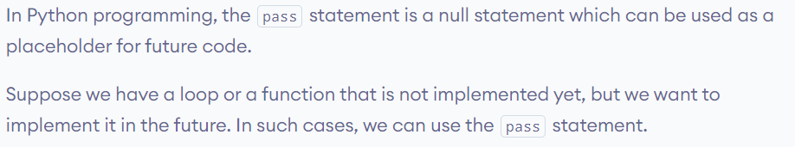

## Type conversion

Int(string_var) or str(inta-var)

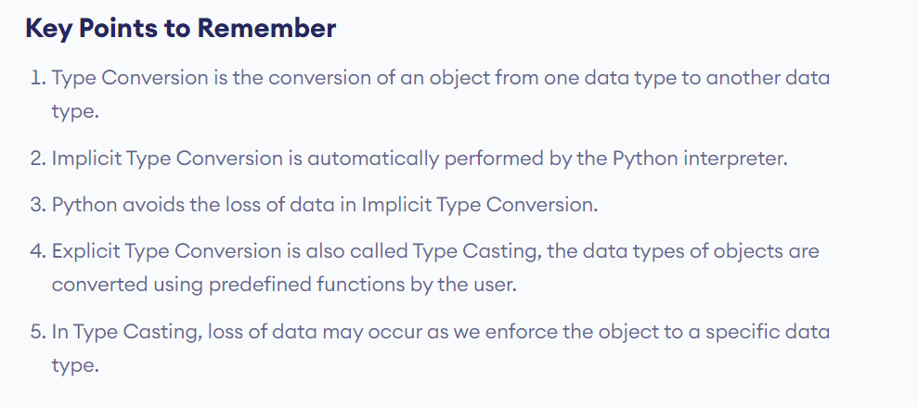

Every Programming Language starts with and developed in the scope of >

* Object Oriented Programming
* Object and Data Structures
* Methods and Functions
* Errors and Exception handling
* Control Flow Statements

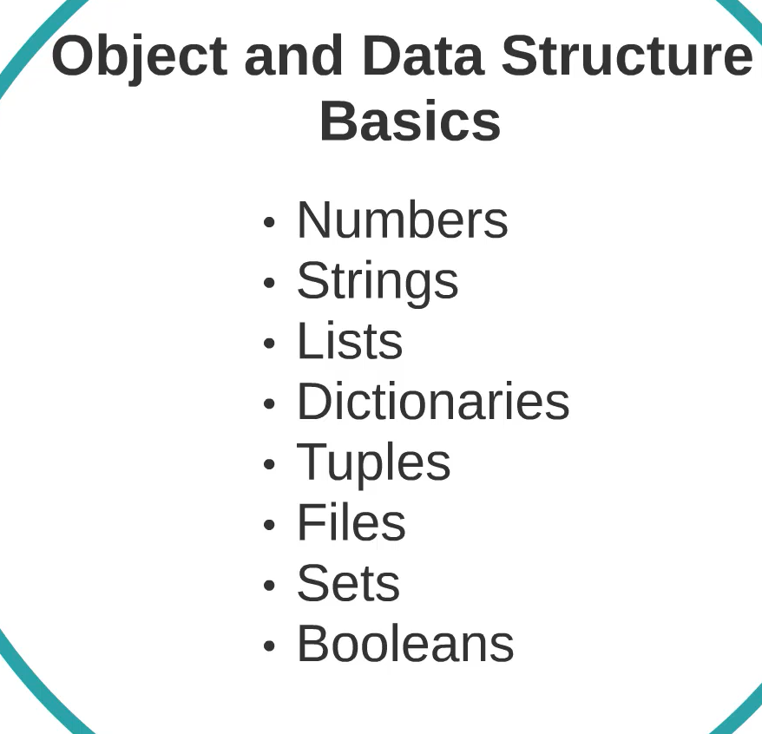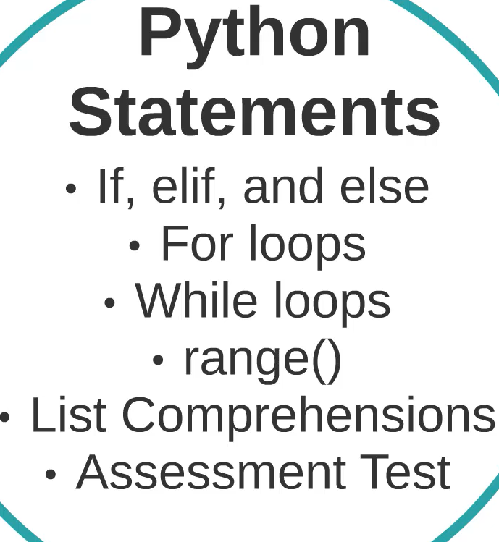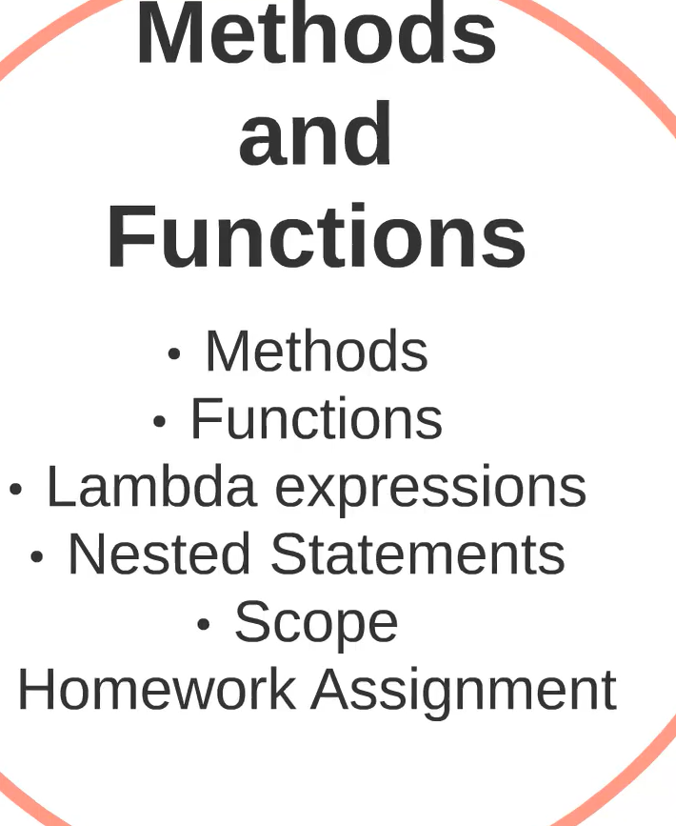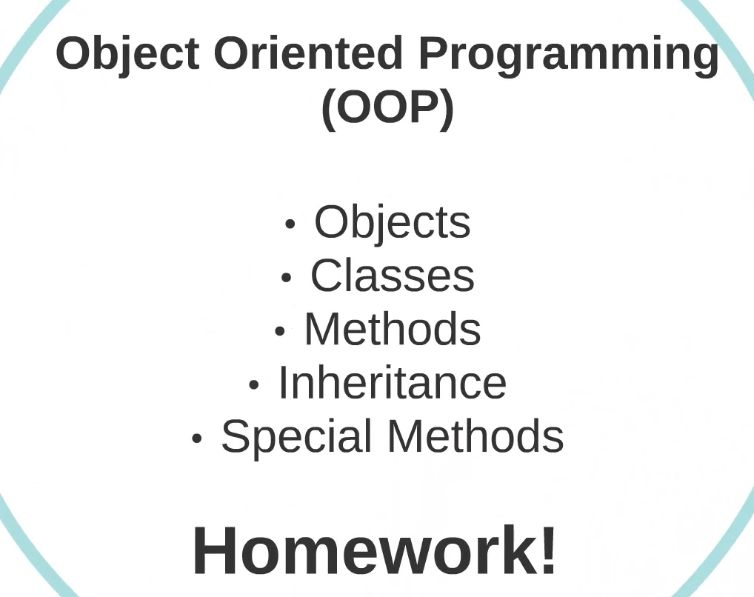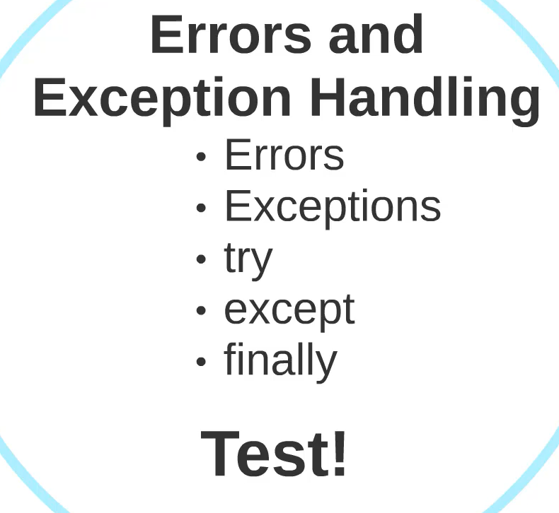

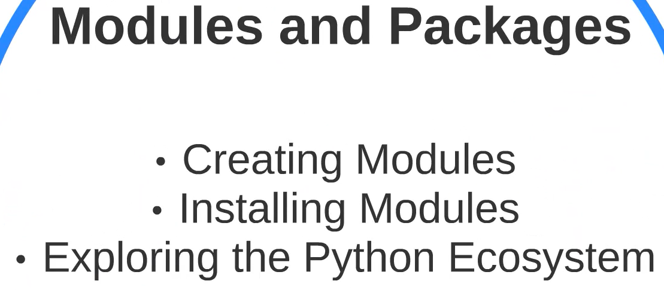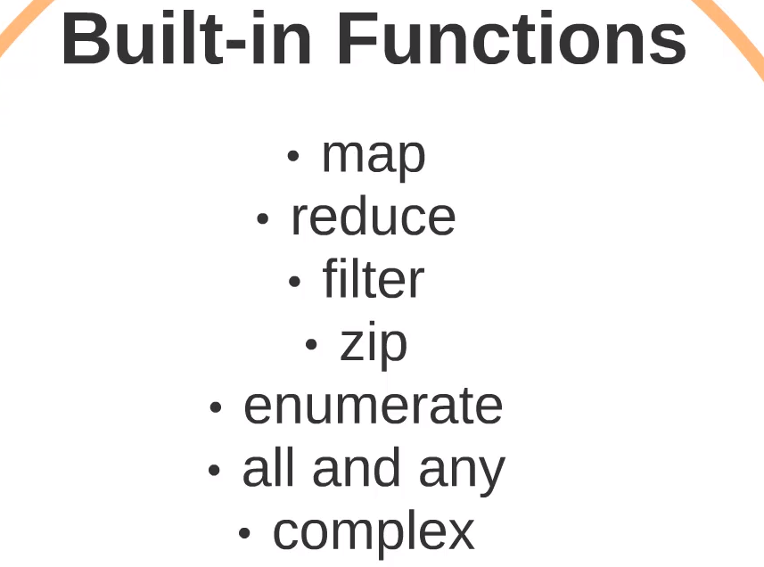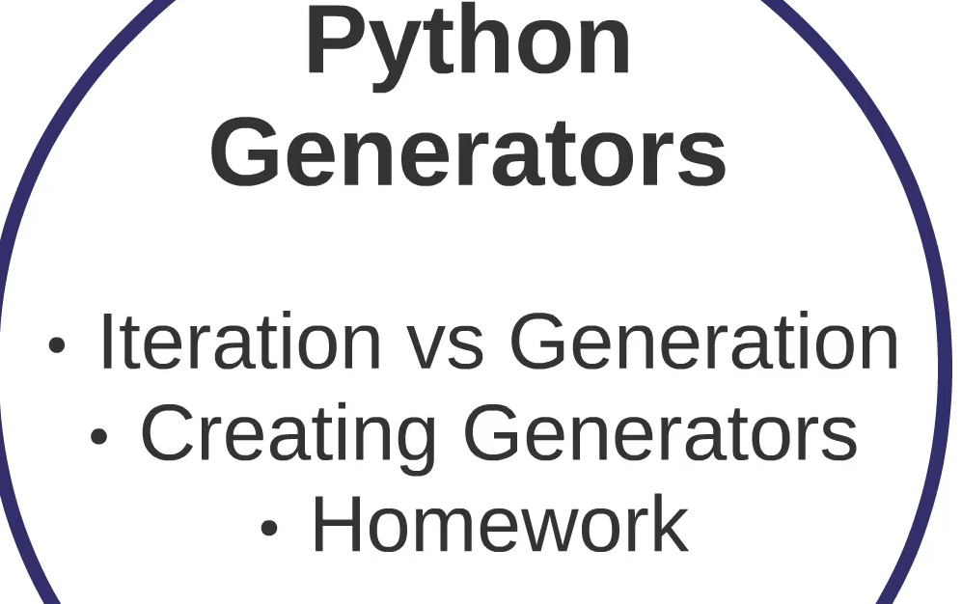

# Python Datatypes and Data Structures

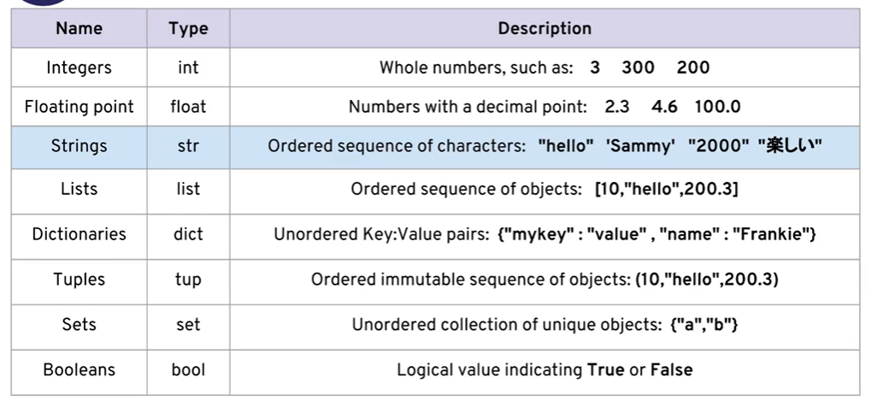

Python does not have a separate character type. It considers as string data type.

Python is Dynamically typed, use **type()** to find the data type of an variable. Not like other statically typed languages.

\n – new line & \t tab space

Slicing and Indexing in strings

Chars in string can access by indexing str[0] – features in java script and python

Negative indexing also allowed in python str[n-1]

***Slicing – str[start:stop:stop]***

Start at index

Stop – skips the index char -jumps

Stop – end the slicing

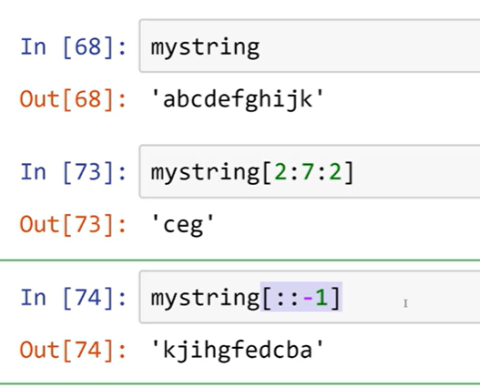

Immutable , because strings are more than variable data type not mutable by indexing -Objects just reference the same address. If changes in string it stored in new address.

str[1] = ‘q’; the 1 position won’t changes to q.

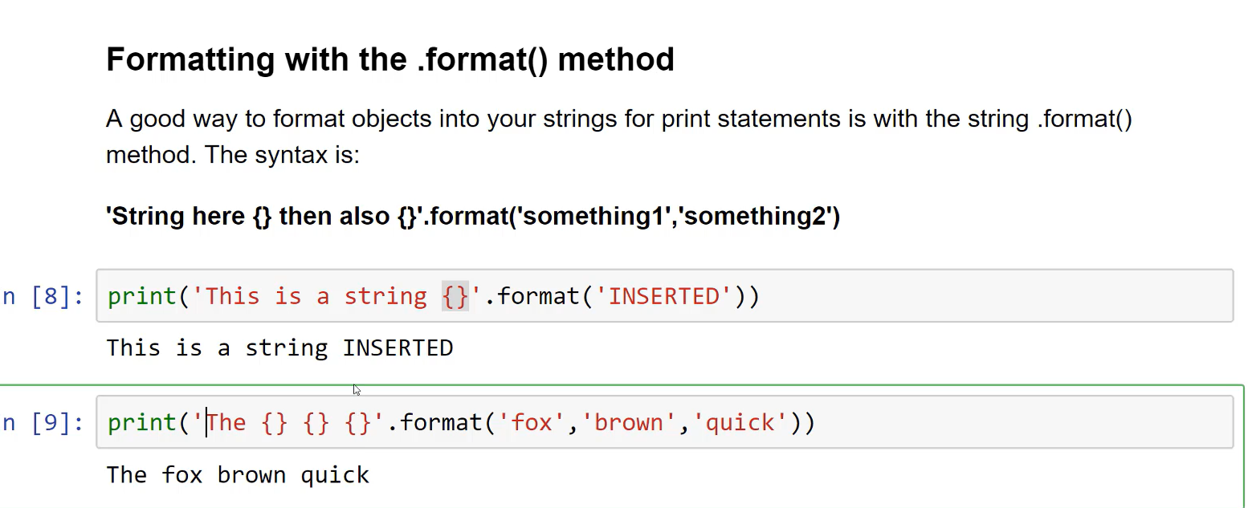

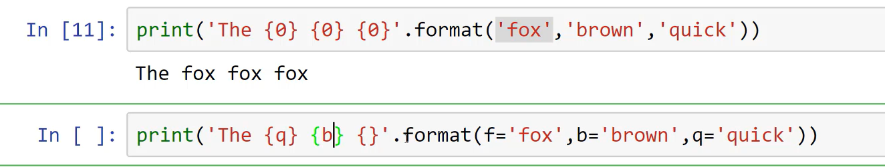

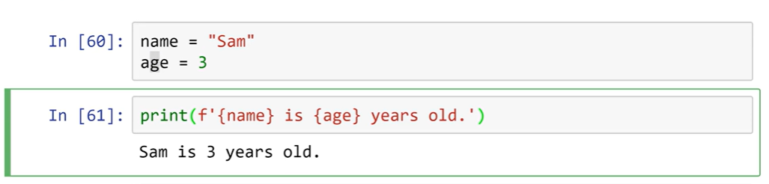

## List in Python

For String we seen Indexing, Slicing, and formatting.

Same Slicing and indexing works for lists as same as strings

append – is used to push an element to list at last index.

pop- is used to remove an element from last index, can be pass the index to pop to remove target index.

sort() – is used to sort an list.

reverse()- to reverse list.

## Dictionaries in Python

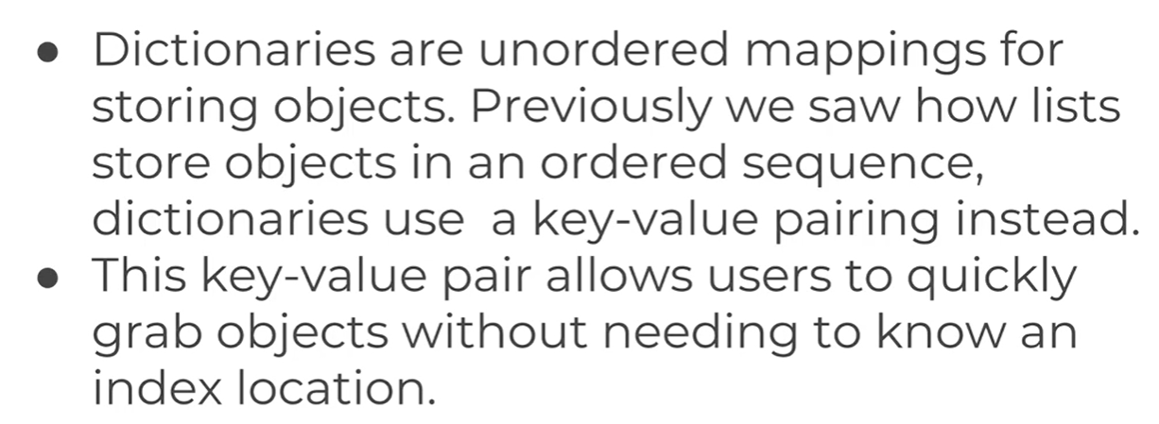

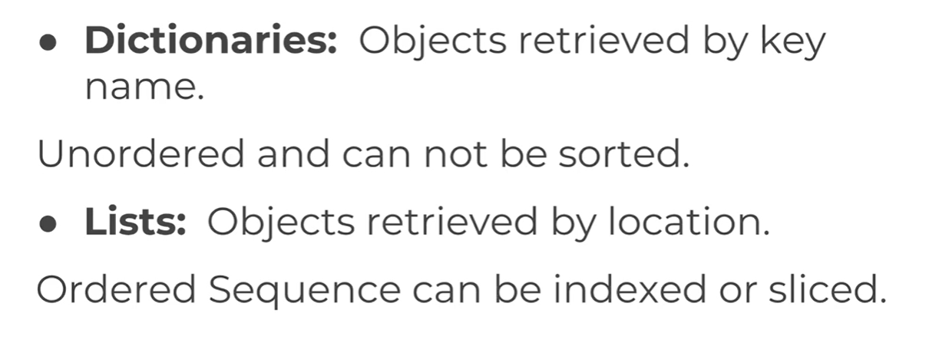

Formed with {key: value}, Uses key in index to retrieve.

Dictionaries are mutable and won’t follows order of sequence.

## Tuple in Python

Similar to list but immutable – tuple =(“d”,”dwsd”)

count() – is used to count the number of occurrences a passed value in tuple.

Index() – to get the index of passed value

## Sets in Python

myset = set() – it won’t store duplicate values.

add – is used to add value to the in ordered set.

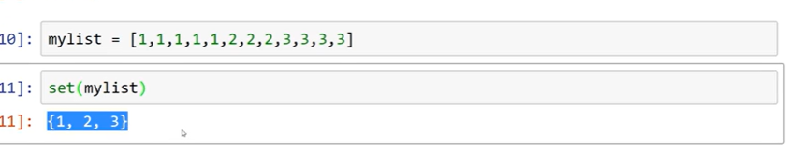

Boolean True or False , if an variable is none it conditional check is False.

## Files in Python

write open read seek(0) close()

**open()** – to open the file and based on mode mentioned the file operation is permitted to do

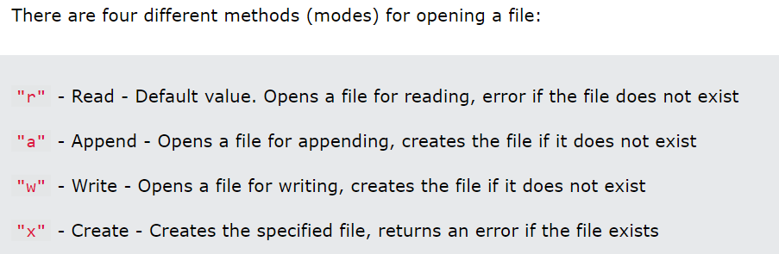

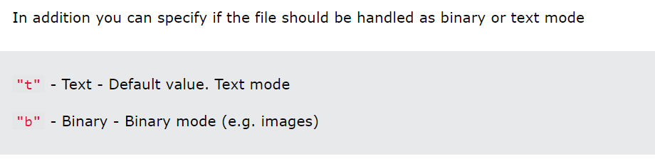

Open File:

f = open("demofile.txt", "rt")

Read File:

print(f.read())

to read only few parts of file - print(f.read(**5**))

Read Lines method returns the data in line by line

f = open("demofile.txt", "r")  
print(f.readline())

The readlines() method returns a list containing each line in the file as a list item.

f = open("demofile.txt", "r")  
print(f.readlines(33))

f.close()

to remove an file:

import os  
os.remove("demofile.txt")

To write in file use mode “a” or “w”

To write to an existing file, you must add a parameter to the open() function:

"a" - Append - will append to the end of the file - put

"w" - Write - will overwrite any existing content - post

f = open("demofile2.txt", "a")  
f.write("Now the file has more content!")  
f.close()   
  
#open and read the file after the appending:  
f = open("demofile2.txt", "r")  
print(f.read())

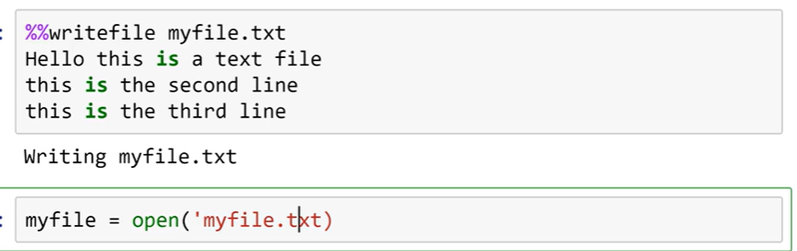

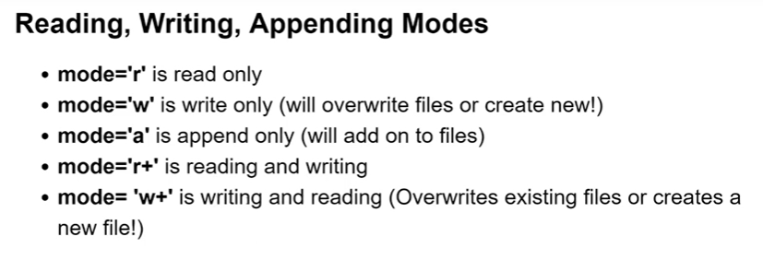

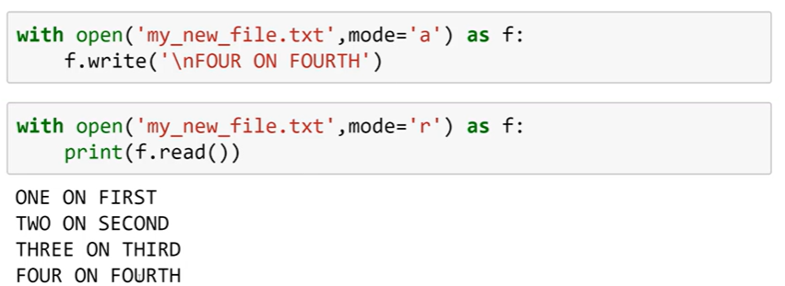

## Control flow statements in Python

Control flow mainly depends on indentation.

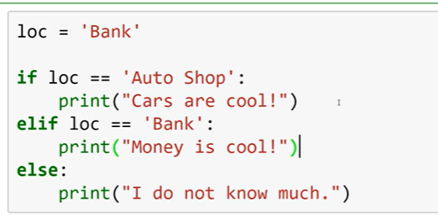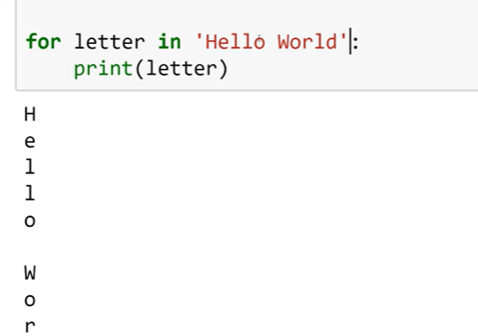

Using for loops iterating through the tuple, dictionaries, sets , and list is possible **simple for i in collection**

Where for the dictionaries can use **for i in d.values(): OR for i in d.keys():**

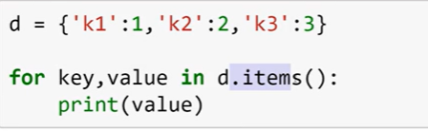

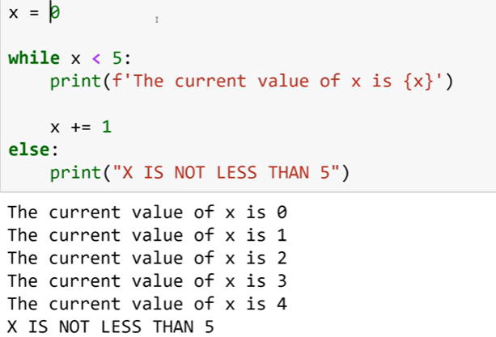

In loops **break, continue, and pass** can be used

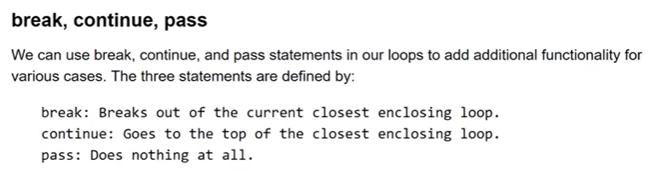

## Use full operators

**range,**

**enumerate returns item as tuple**

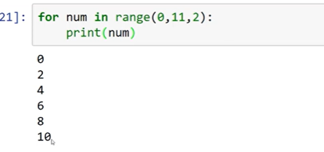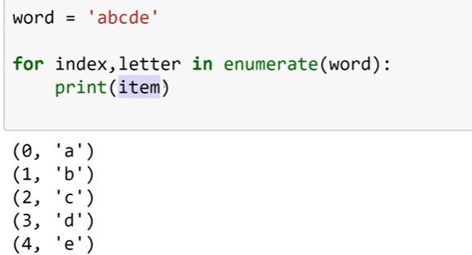

**zip** is used return the different data structures into tuple when iterating. FIRST INDEX elements are returns as each tuple

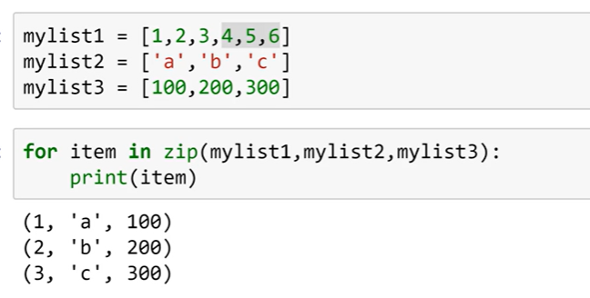

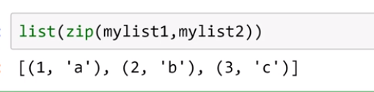

in can be used to check whether the value or key present in collection

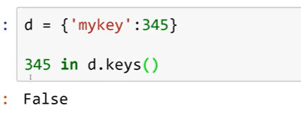

And also max and min can be used in collection to get min nd max values

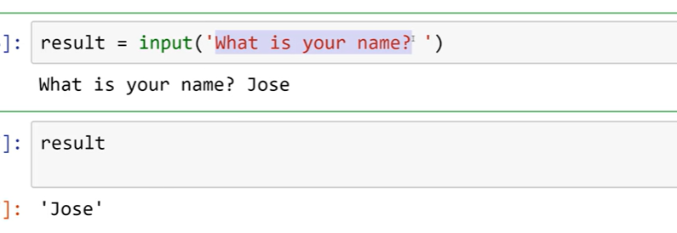

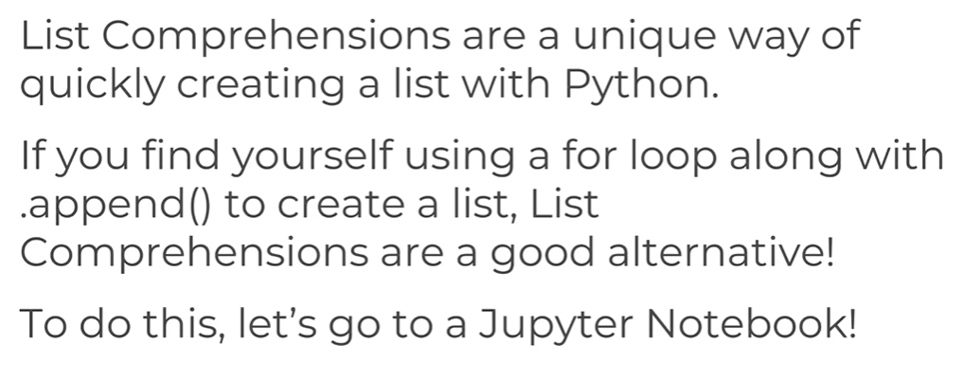

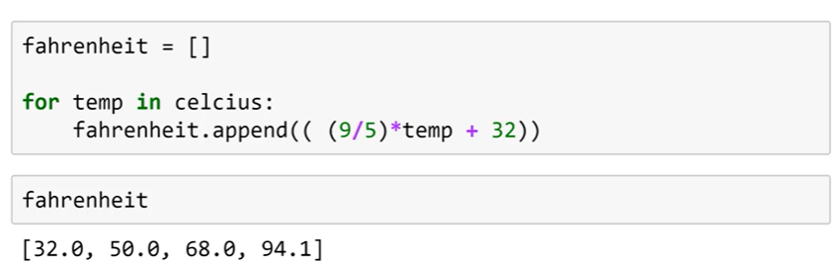

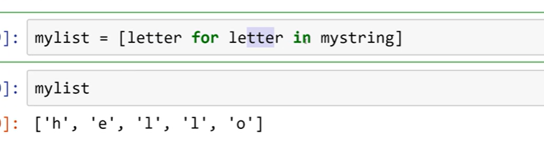

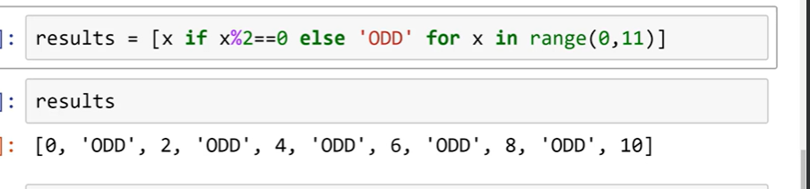

# Methods and Functions in Python

Methods are built-in library functions to speed-up the development.

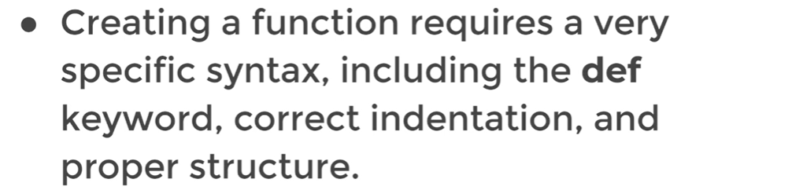

Functions can be called and assign to another variables like , when used the () brackets function will be called , when just only function mentioned it means can access the function.

## *args and *kwargs

Placing args as parameter to the function, it takes as many as parameters when it’s calling.

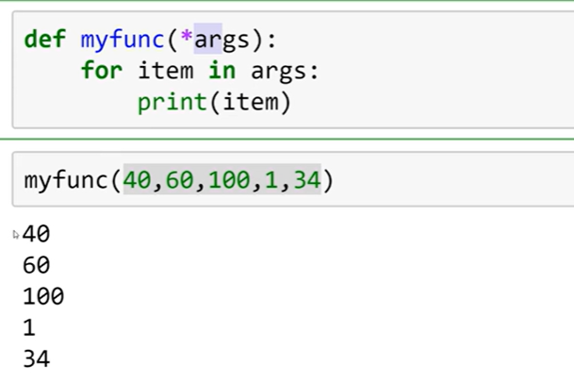

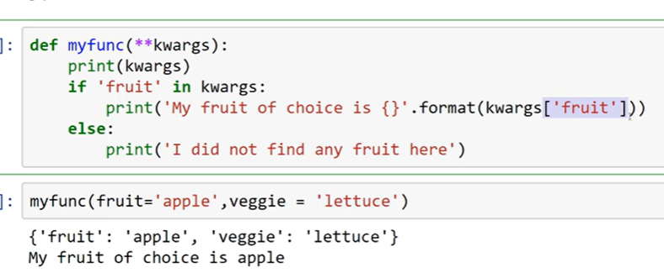

kwargs returns the dictionary as liswt. And allows to pass arguments as key and value.

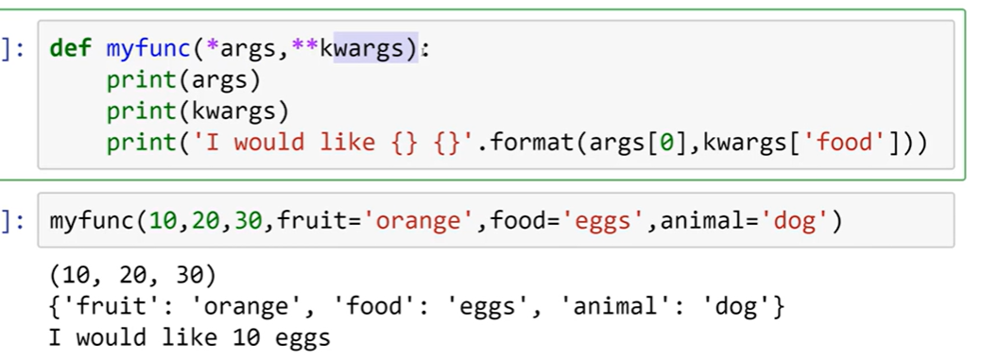

*args is list where **kwargs is dictionary

# **Lambda Expressions – Map and Filter**

map(function, list)

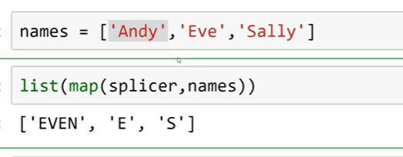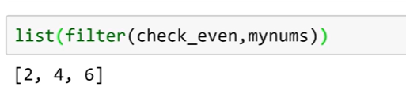

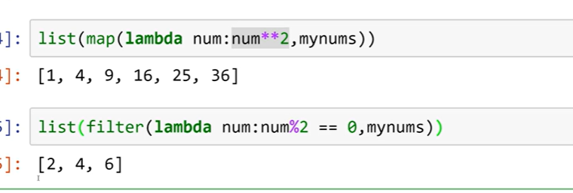

# **Nested and Scopes**

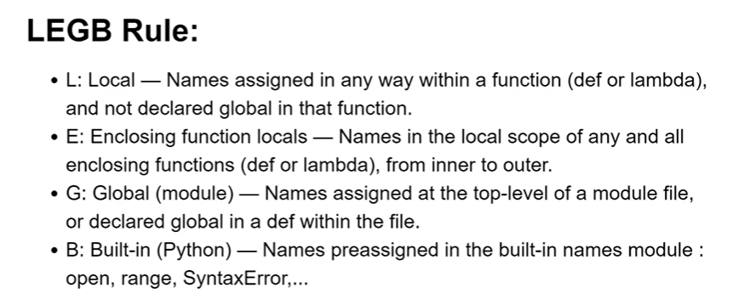

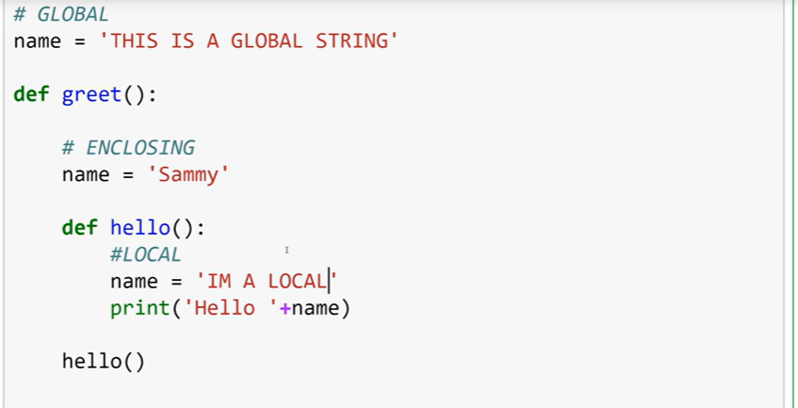

# **Object Oriented Programming in Python**

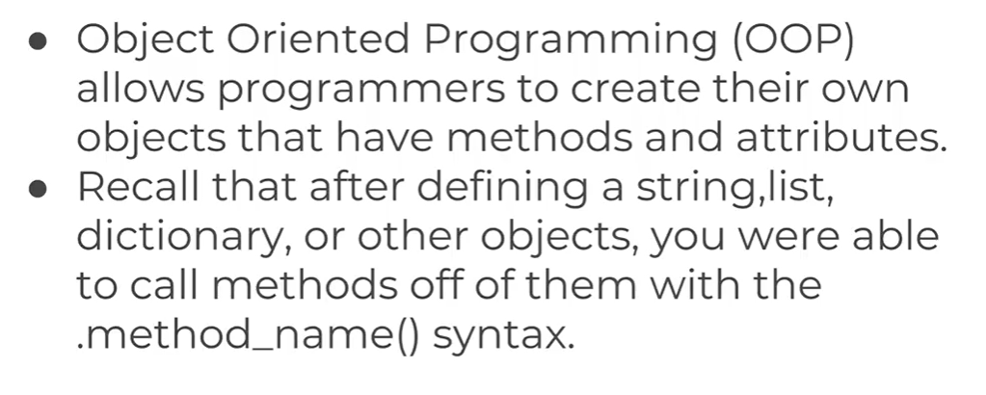

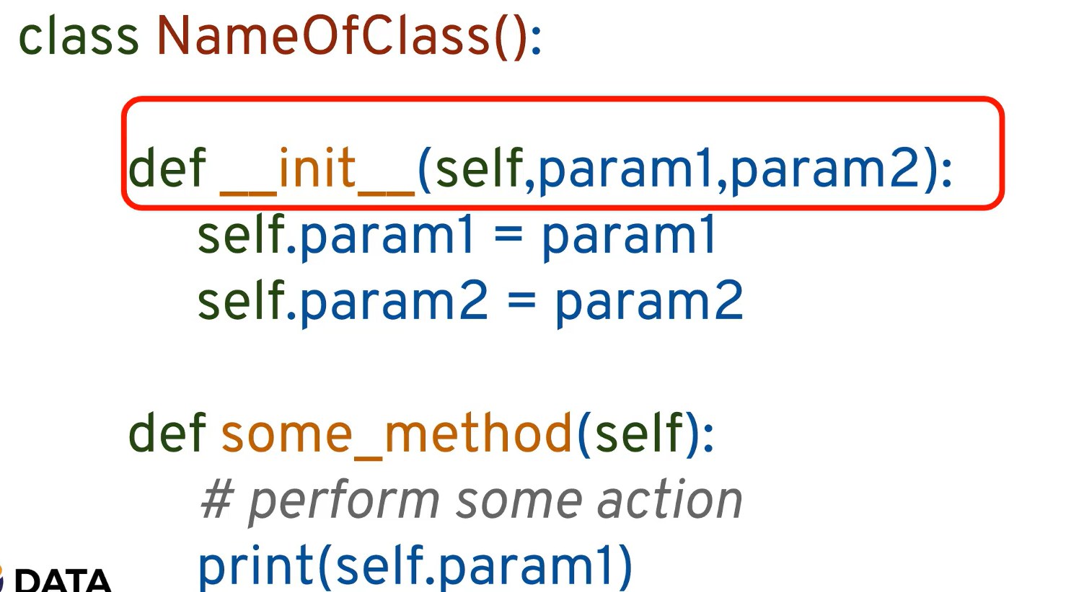

init function a object initializer and constructs the object when object is called with the defined attributes.

TO access the Attributes in side the class self is used to do it as self is reference of the current object as this in JAVA.

## Inheritance

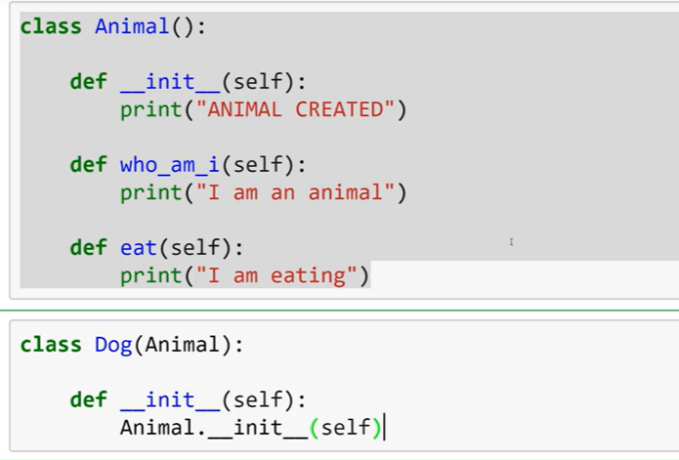 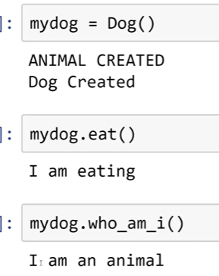

## **Polymorphism**

Method overriding – the execution of method depends on the instance created at the time of object initialization.

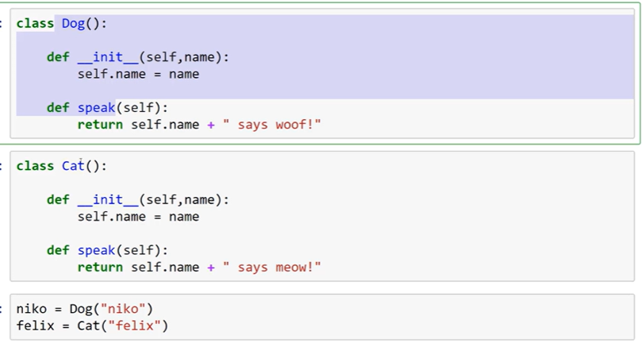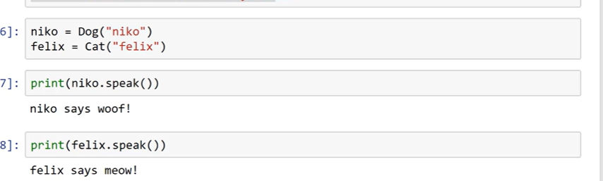

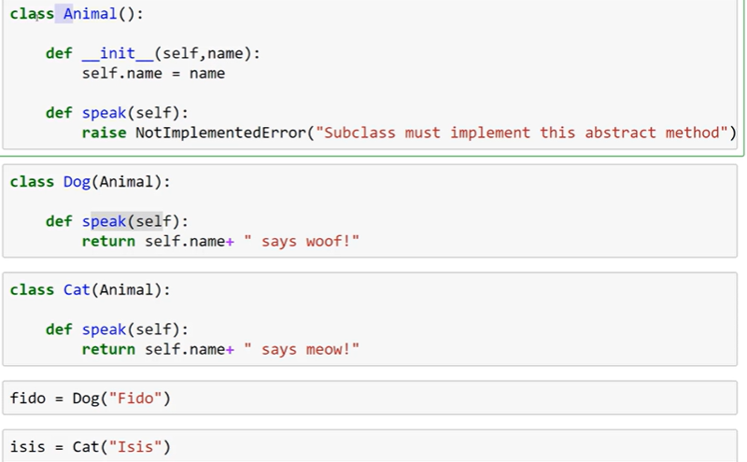

## **Special Functions – Operator overloading**

Operator overloading in Python allows you to define or redefine the behaviour of operators for user-defined data types. This means you can make objects of your class work with Python's built-in operators like **+**, **-**, **\***, **/**, and many others.

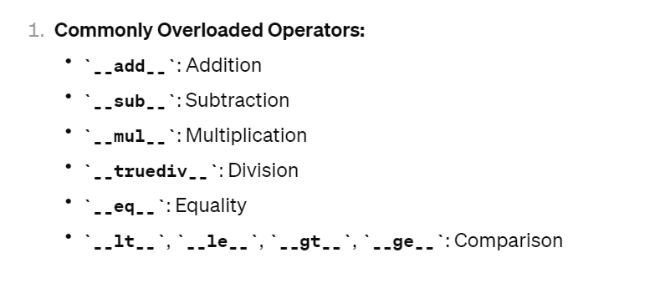

The use defined objects won’t have the built in functions, so these special functions are used.

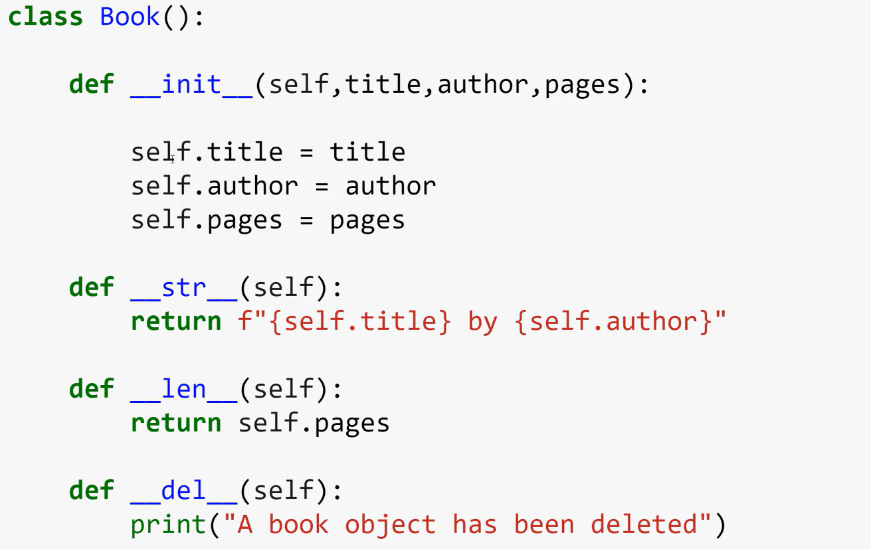

Python Modules and Packages are managed and installed from PyPi pip

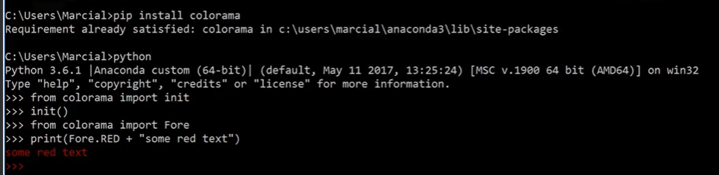

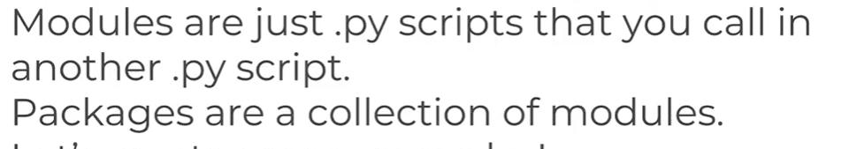

__init__.py tells a directory is a package.

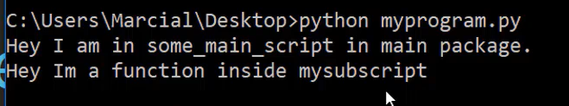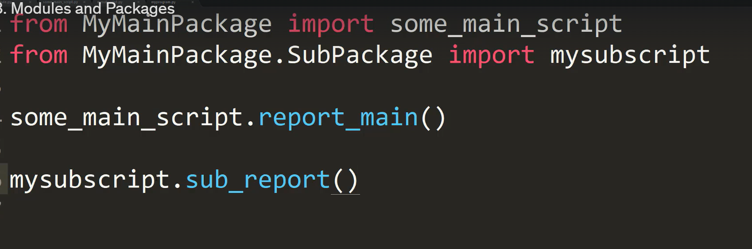

Two differentiated between the call by imported or directly called the below example well explains

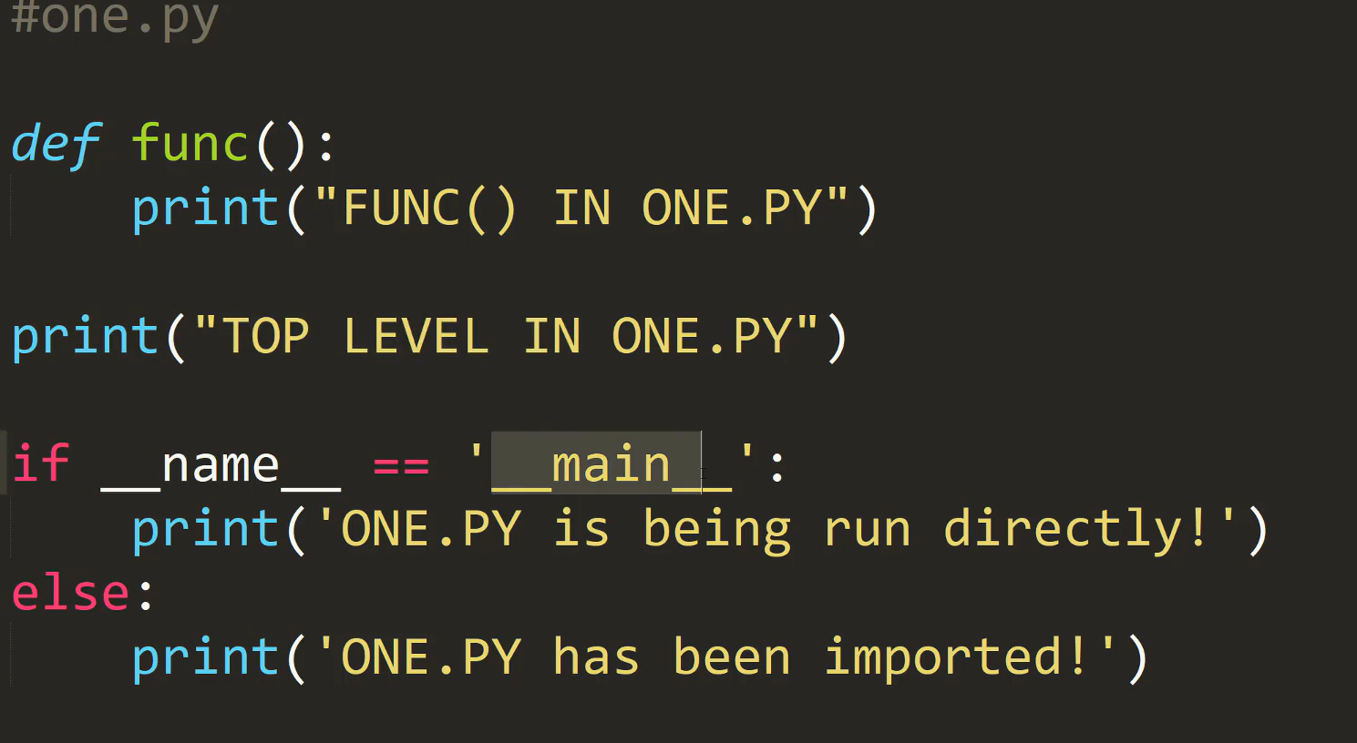 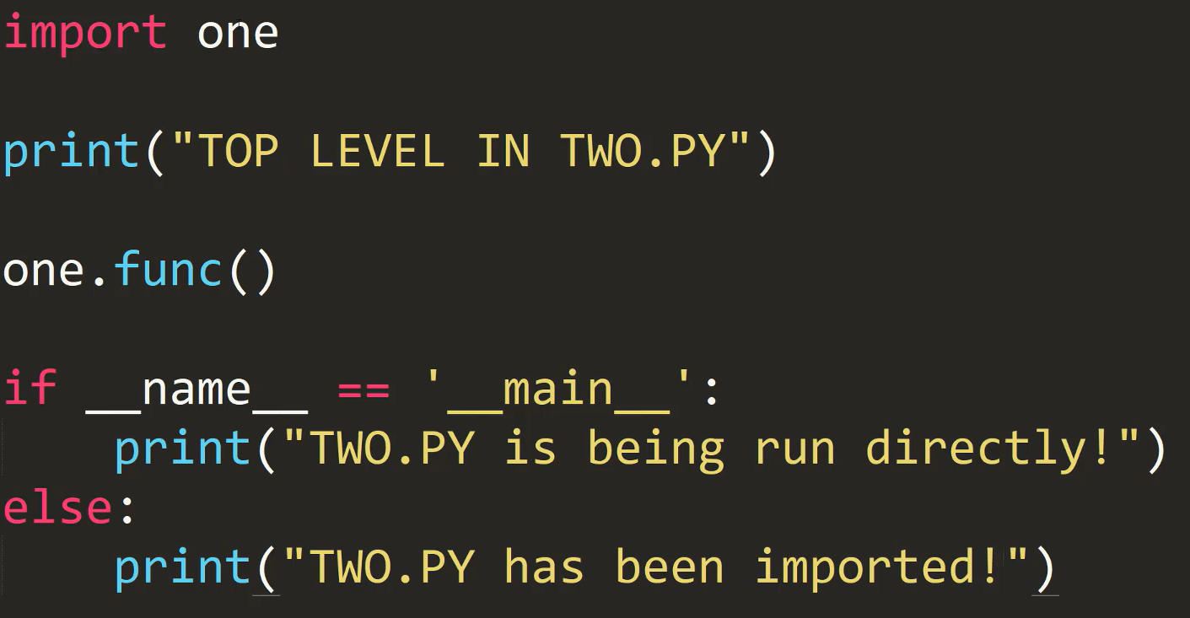

So this way executing the functions fro various purposes

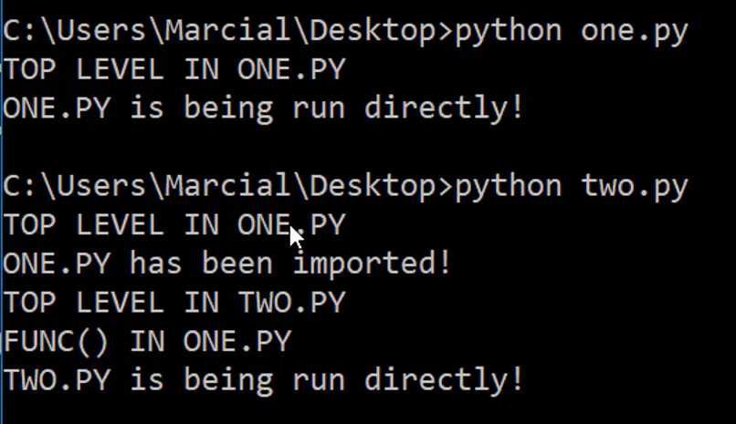

# **Errors and Errors Handling in python**

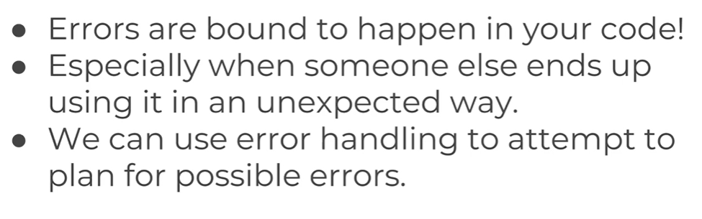

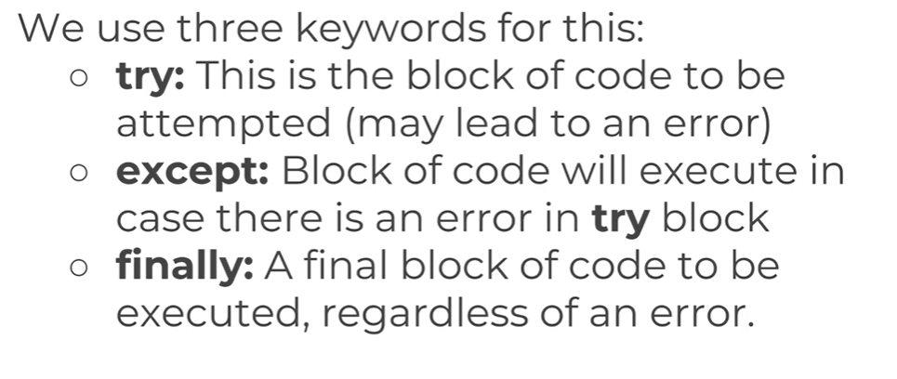

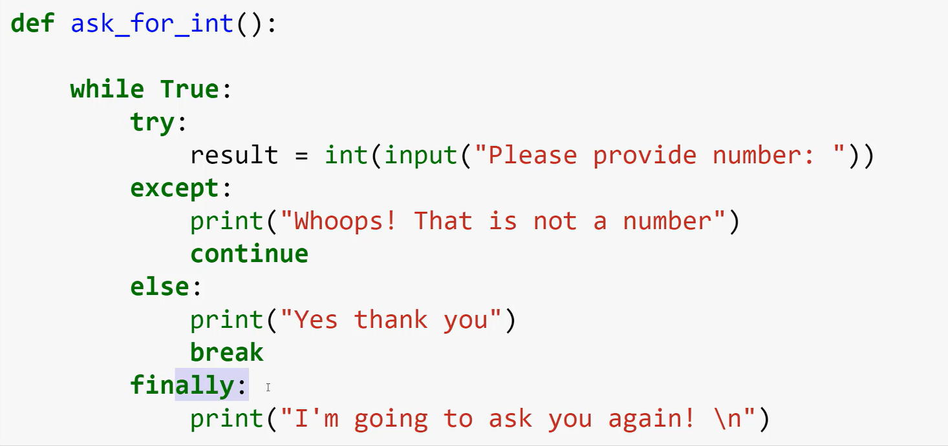

# Regular Expressions - matching patterns in text

A RegEx, or Regular Expression, is a sequence of characters that forms a search pattern. RegEx can be used to check if a string contains the specified search pattern. String Identifier, Character Identifiers. Group is used to get the returned string.

Import re

regular expressions (regex) can seem complex at first, but they are a powerful tool for matching patterns in text. Here's a breakdown of their structure and how to use them:

**Basic Building Blocks:**

* **Characters:** Regular expressions can match literal characters like a, b, #, etc.
* **Metacharacters:** These characters have special meanings within regex patterns. Some common ones include:
  + . (dot): Matches any single character except newline.
  + *: Matches the preceding character zero or more times.
  + +: Matches the preceding character one or more times.
  + ?: Matches the preceding character zero or one time.
  + ^: Matches the beginning of the string.
  + $: Matches the end of the string.
  + []: Character class (e.g., [a-z], [0-9]) matches any character within the brackets.

**Constructing Patterns:**

* Regular expressions are formed by combining characters and metacharacters to define a pattern.
* The order matters, as the regex engine reads from left to right.

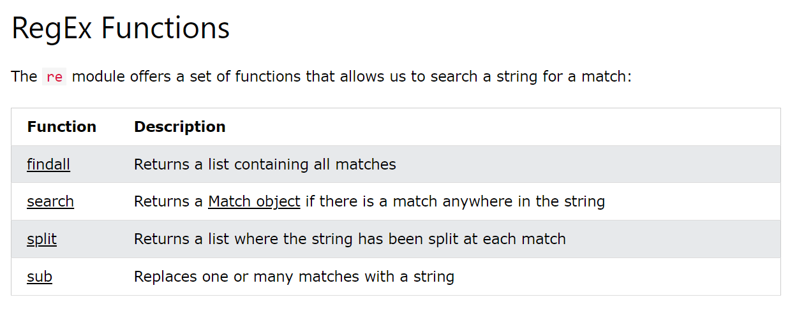

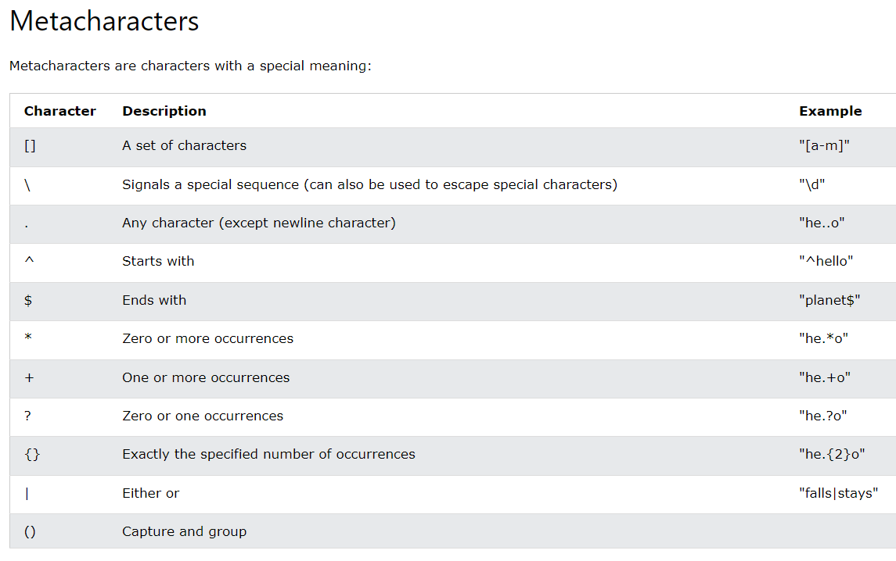

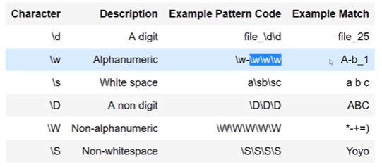

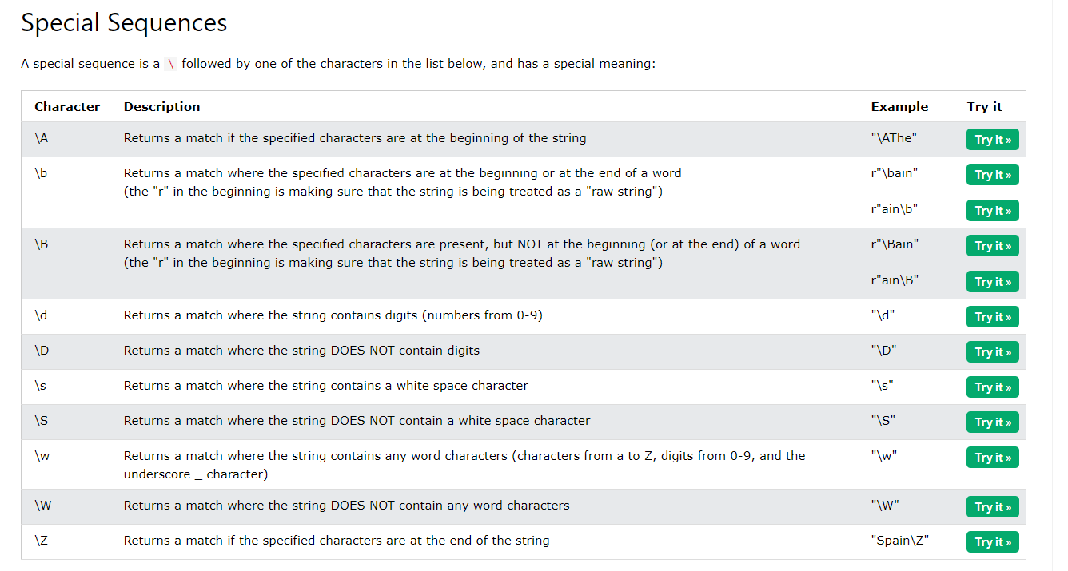

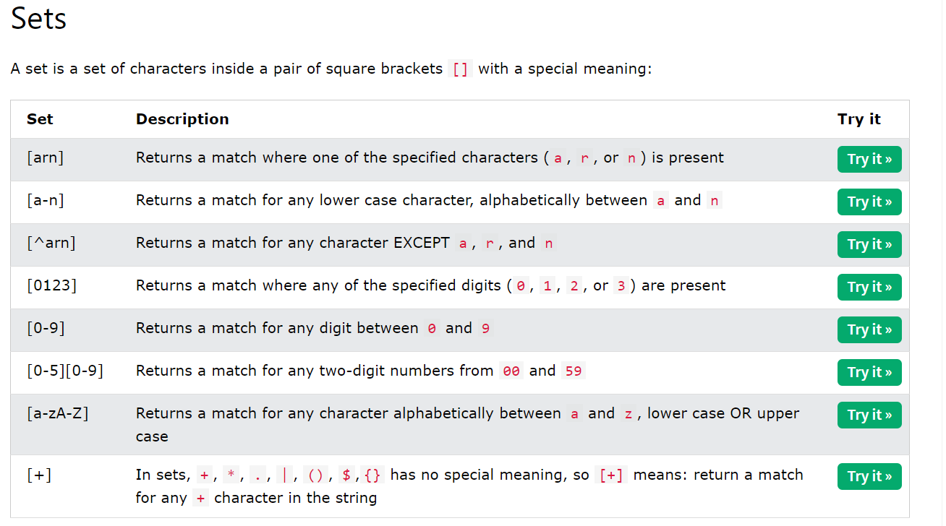

When the pattern is large

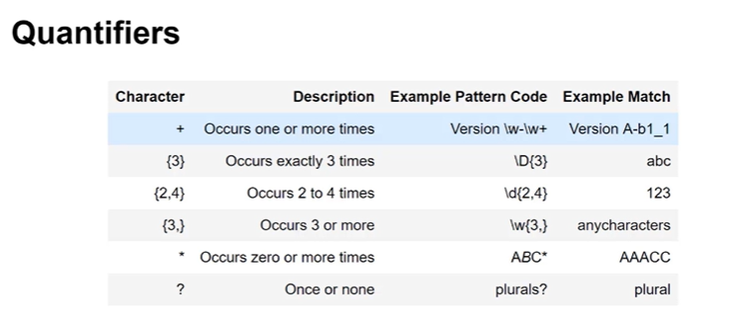

# Python Json

Import json

As in Java script we use fetch api to fetch the data from URL, In python the **request** package is used fetch the data from.

The data fetched from the server are in the form of json and the data we send to server must be in the form of Json format.

**To convert the data into object/ Dictionaries , json.loads(data)**

**To convert the data into Json format -> json.dumps(data)**

# Python Libraries:

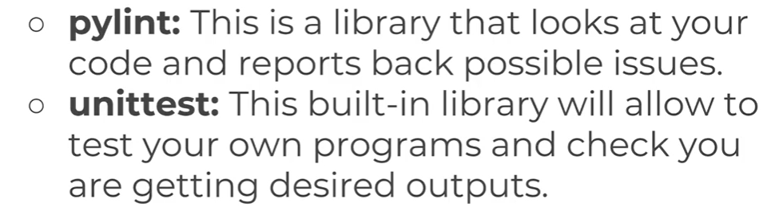

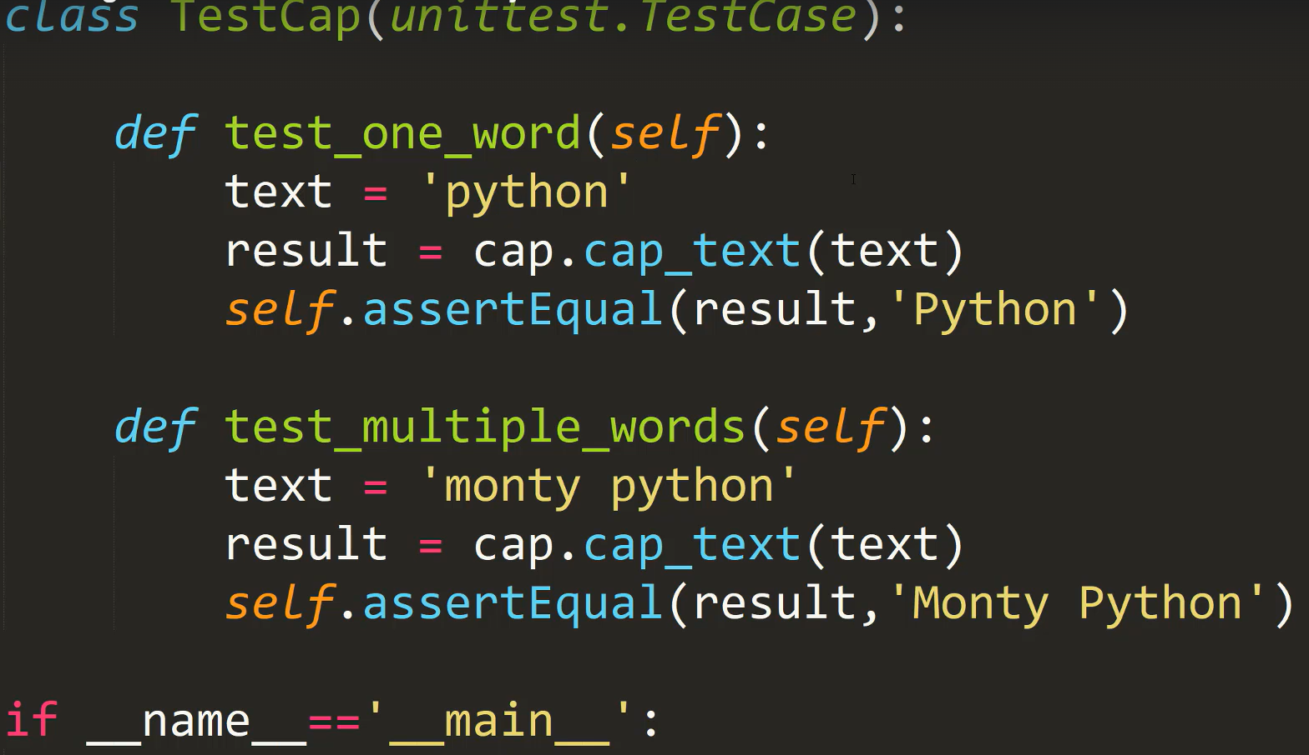

# Python Decorators

To Decorate Functions – Enhancing the functions with at annotation , a decorator is a function that takes another function and extends the behavior of the latter function without explicitly modifying it.

Decorators provide a simple syntax for calling [higher-order functions](http://en.wikipedia.org/wiki/Higher-order_function).

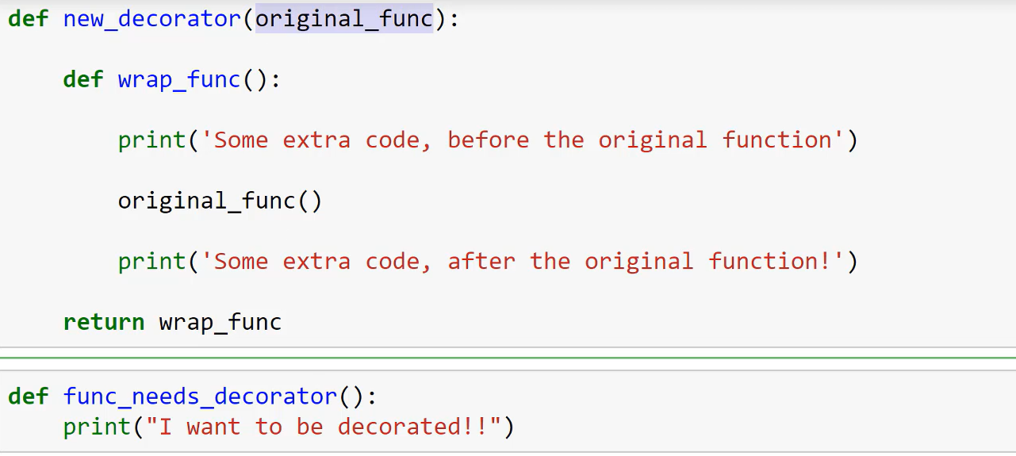

Decorators are special functions , which dynamically modifies the behaviour of a functions or classes. Using @decorator_func makes the following function argument for decorator function.

Where Decorator function takes function as argument and returns a wrapper function with modification to either before or after or around the actual function calling. Where the function passing and managing args or kargs is done by decorator in backend.

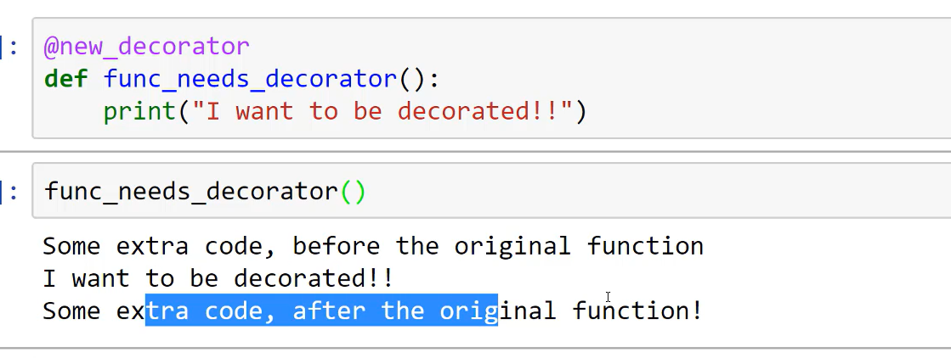

# **Generators in Python**

Which plays a key role in memory usage by holding the state of object rather storing full content of object nor processing it at same time.

It follows the iterator and with yield rather single return, once the current value handle over to user, the next function resume the iteration again.

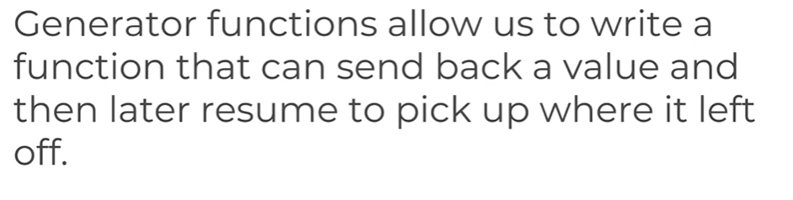

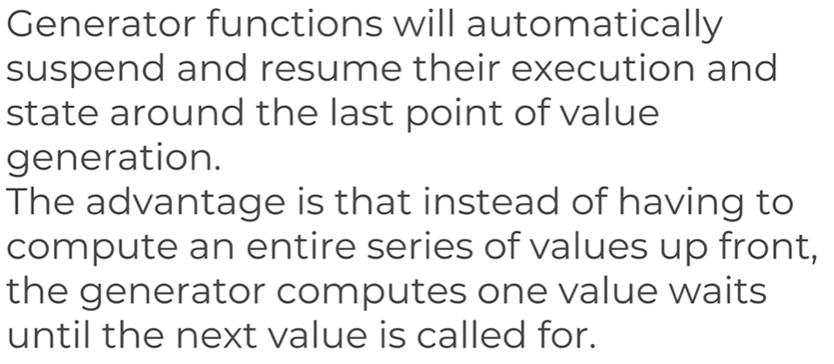

Generators play a crucial role in optimizing memory usage when dealing with large datasets or infinite sequences in Python. Here's why:

**Memory Challenges with Large Data:**

* When working with large datasets, storing the entire data structure in memory at once can be inefficient and lead to memory exhaustion.
* Traditional approaches like lists or NumPy arrays can consume significant memory, impacting performance, especially for limited resources.

**How Generators Help:**

* Generators act as iterators, providing a way to access elements of a sequence one at a time on demand.
* They don't hold the entire sequence in memory at once.
* Instead, they generate elements only when requested, using memory efficiently for processing large datasets.

**Benefits of Generators:**

* **Reduced Memory Footprint:** Generators require minimal memory compared to traditional data structures.
* **Processing Large Datasets:** You can process very large datasets without running out of memory.
* **Lazy Evaluation:** Generators only evaluate the expression when needed, further saving memory.
* **Streaming Data:** Generators are ideal for streaming data from external sources or infinite sequences.

**```**

# Inefficient approach (stores entire list in memory)

large_list = list(range(10000000)) # Create a list with 10 million elements

# Efficient approach (uses generator)

def large_generator():

for i in range(10000000):

yield i # Yield elements one at a time

large_gen = large_generator() # Create a generator

# Access elements one at a time

for element in large_gen:

print(element) # Process each element without storing the entire sequence

# Generator only holds state, not the entire sequence in memory

**```**

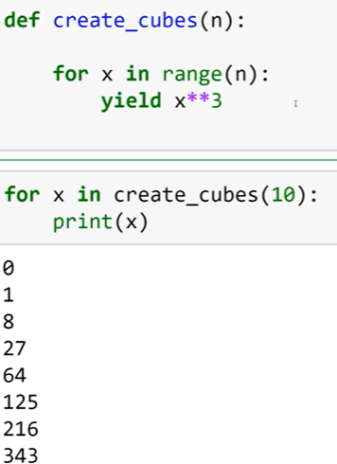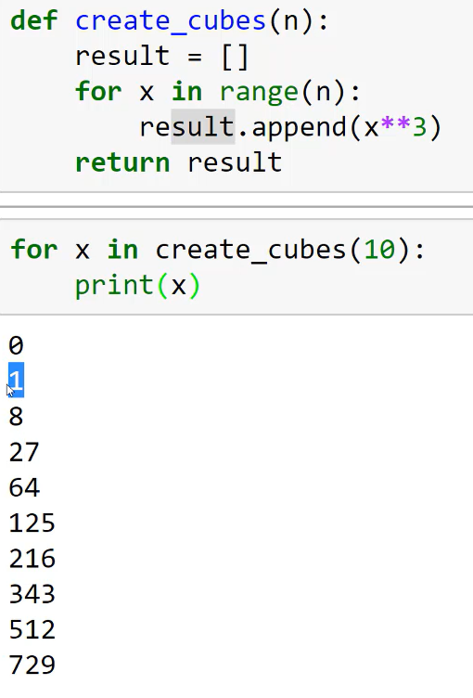

Python have inbuilt iter function to iterate through the object, it works as generator function , every element can be retrieved with next(attribute)

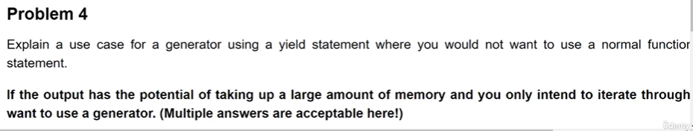

# **Collections in Python**

Counter to count the number occurrence of an element in list

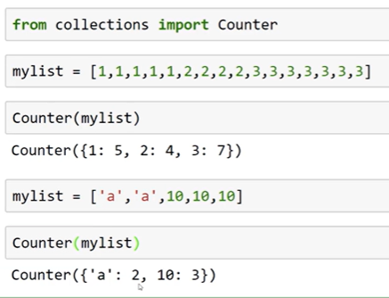

defaultdict() – the default value for any key if present or not is ZERO

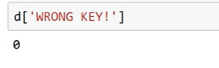

namedTuple – it has a ability to make tupple has dictionary

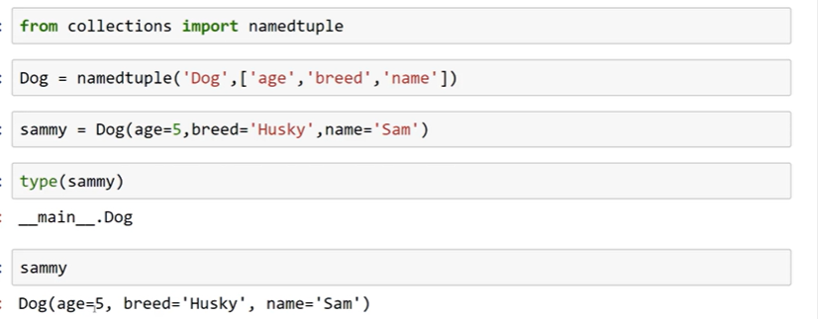

# **OS and Shutil packages in Python:**

OS offers-> os.getcwd, os.listdir(path)

for folders, sub_folders, files in os.walk(folder):

os.walk() – method offers to divide the path into folders, sub_folders, files .

os.getenv(“key”)

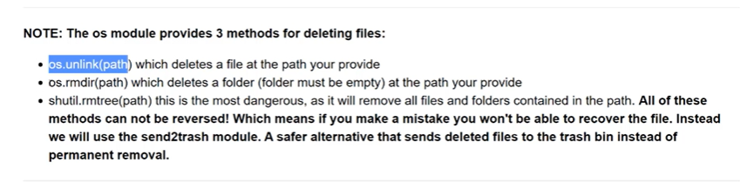

shutil is used move the files -> shutil.move(“sample file”, “target_path”)

using send2trash package file can be send to trash from python

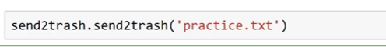

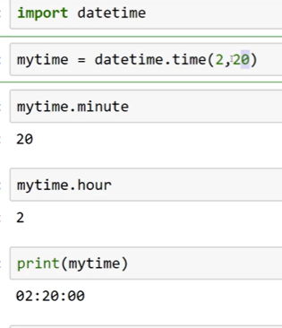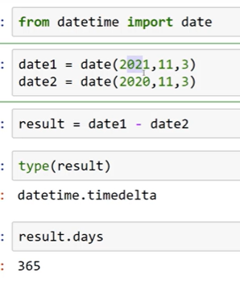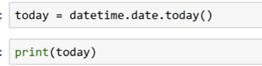

Math and random

# Zip and UnZip in Pyhton

Import zipfile

os.getcwd()

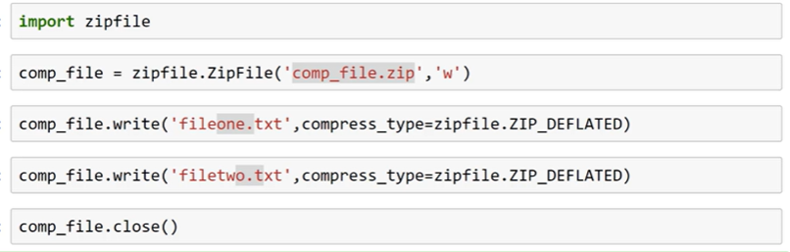

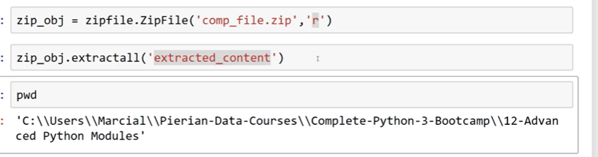

# FAST API:

## Asynchronous Communication in FastAPI:

FastAPI leverages the ASGI (Asynchronous Server Gateway Interface) specification to facilitate asynchronous web development. ASGI establishes a standardized way for web servers (ASGI servers) to interact with web applications (like FastAPI) in a non-blocking manner. REST APIs define the communication style between client and server, ASGI provides the underlying mechanism for efficient asynchronous communication

This enables a single server process to handle numerous concurrent requests efficiently. Here's a breakdown of the key aspects:

* **Non-Blocking I/O Operations:** Unlike traditional synchronous approaches where the server waits for a client's response before handling the next request, ASGI allows for non-blocking I/O operations. This means that when a server writes data (sends a response) to a client socket, it doesn't wait for the client's acknowledgment before moving on to process other requests. This boosts performance as the server isn't idle while waiting for I/O operations to complete.
* **Event Loop and Callbacks:** In the heart of the asynchronous framework lies the event loop. This component acts as a central coordinator that manages asynchronous tasks and handles incoming events. When a non-blocking I/O operation initiates, the event loop doesn't hold up the execution. Instead, it registers a callback function with the operating system. When the requested operation (e.g., network communication) is finished, the operating system notifies the event loop, which then triggers the registered callback function to process the response or error.

**Client-Server Interaction:**

the role of ASGI servers in FastAPI's asynchronous approach.

* **Client-Server Connection:** In RESTful API architectures, client applications establish connections with server APIs using protocols like HTTP. Client sockets are typically not directly involved in this communication within modern web frameworks like FastAPI.
* **ASGI Server as Interface:** The ASGI server in FastAPI acts as an intermediary between the client and the web application. It receives incoming HTTP requests from the client, triggers the FastAPI application to handle the request asynchronously, and sends the response back to the client.

**Advantages of Async Operations:**

* **Scalability:** By handling numerous requests concurrently without blocking, FastAPI can handle more requests with fewer server resources, leading to improved scalability for high-traffic applications.
* **Responsiveness:** As the server isn't tied up waiting for individual requests to finish, it can provide quicker overall response times, especially for operations that involve network I/O (like database interactions).

**Key Considerations:**

* **Code Structure:** Writing asynchronous code using ASGI patterns can require a different mindset compared to traditional synchronous approaches. Familiarity with asynchronous programming concepts like async/await syntax and asynchronous iterators is crucial.
* **Error Handling:** Handling errors in asynchronous code can be more nuanced than in synchronous applications. Asynchronous code often involves awaiting multiple operations, and errors may need to be handled using appropriate mechanisms like try...except blocks and asynchronous context managers.
* **Testing:** Testing asynchronous FastAPI applications can also have its own considerations. Familiarize yourself with tools designed for testing asynchronous code in Python.

As **FastAPI** is based on Starlette and implements the ASGI specification, you can use any ASGI middleware.

ASGI stands for Asynchronous Server Gateway Interface. It is a specification that defines how web servers communicate with web applications or frameworks in a standard way. ASGI is designed to support asynchronous and concurrent processing, allowing web applications to handle multiple requests simultaneously and efficiently.

ASGI servers, like uvicorn and daphne, are responsible for receiving incoming HTTP requests, passing them to the web application or framework, and then sending the response back to the client. ASGI servers provide the necessary infrastructure to handle the HTTP protocol or websockets and manage the communication between the server and the application.

ASGI is particularly useful for Python web frameworks that support asynchronous programming, such as FastAPI and Sanic. These frameworks take advantage of ASGI servers to achieve high-performance, non-blocking I/O, and handle a large number of concurrent requests efficiently.

Start Server:

 The command uvicorn main:app which starts the uvicorn server and provide FastAPI app which is initialized in the main module

### **Decorators in FastAPI:**

* Decorators are a powerful syntactic feature in Python that allows you to modify the behavior of functions or classes without directly changing their source code.
* In FastAPI, decorators are used to define endpoint functions that handle incoming HTTP requests.
* The @ symbol followed by the decorator function name precedes the endpoint function definition.

Handling Undefined routes:

To handle fastapi is build upon starlette low-level ASGI framework

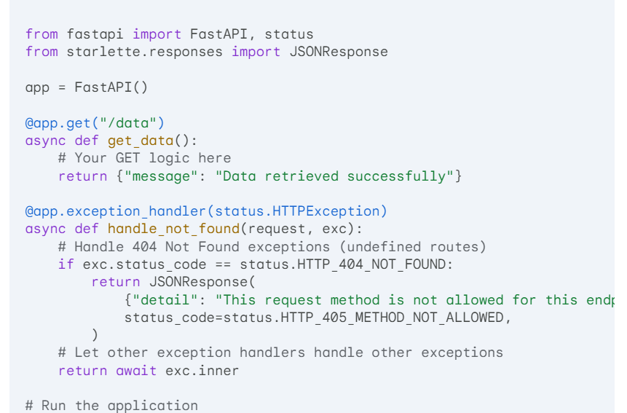

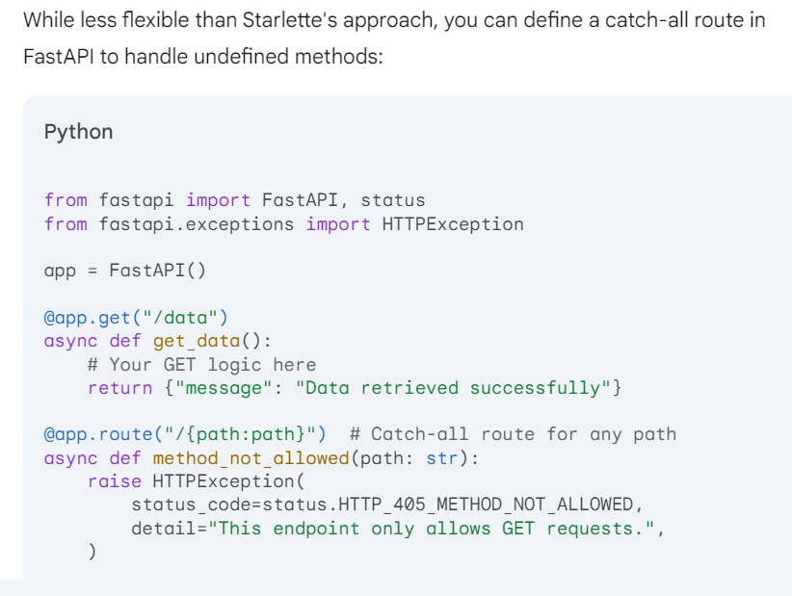

## Route matching(pattern) mechanism: Routing system

FastAPI utilizes a combination of routing and path matching mechanisms to efficiently trigger only the requested endpoint:

**Routing:**

* FastAPI employs an underlying routing system built upon frameworks like Starlette.
* When you define an endpoint function using the @app.get, @app.post, or other method decorators, you're essentially registering a route within the application.
* Each route has a unique combination of attributes, including:
  + HTTP method (GET, POST, PUT, etc.)
  + Path (URL pattern)
  + Endpoint function (the actual code to execute)

**Path Matching:**

* When a client sends an HTTP request, FastAPI receives the request information, including the HTTP method and the requested URL path.
* The routing system iterates through the registered routes and attempts to match the request's method and path to the defined routes.

**Matching Mechanism:**

* **Exact Matching:** If a route's path exactly matches the requested path, that endpoint function is triggered.
* **Path Parameters:** Routes can include path parameters enclosed in curly braces ({param_name}). FastAPI extracts these parameters from the URL path and makes them available to the endpoint function as keyword arguments. For example, a route like /users/{user_id} would match a request to /users/123 and extract user_id=123.
* **Wildcards:** You can use wildcards (*) to match any path segment. This allows for more flexible routing, but use them cautiously to avoid unintended matches.

**Route Order Matters:**

* The order in which you define your routes in the FastAPI application file matters. FastAPI iterates through the routes in the order they are defined.
* If a route with a broader path (e.g., /users/*) is defined before a more specific route (e.g., /users/{user_id}), the broader route might be matched first even if the specific route is a better fit for the request. It's recommended to organize routes from most specific to most general to avoid conflicts.

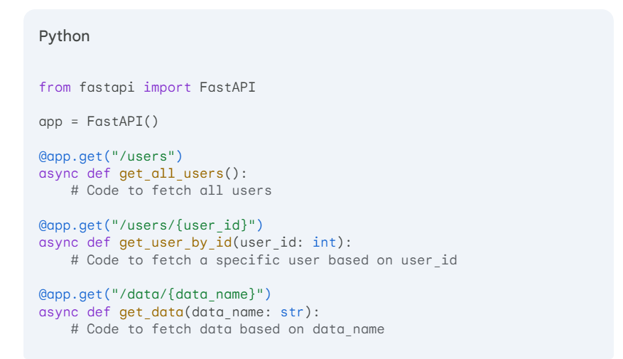

* In this example, if a request comes in for /users/123, the second route (get_user_by_id) would be triggered as it's more specific than the first route (get_all_users).
* Similarly, a request for /data/temperature would match the third route (get_data).

## Dependency Injection in Action: dependency injection system

where developer gets the endpoint data as functional arguments, as these argumentpassed to function is dependencies of that endpoint function so it handled my dependency injection, does it same applicable to classes and function.

Dependency injection and payload handling are key aspects of FastAPI that contribute to its modularity and testability.

**Dependency Injection in FastAPI:**

* FastAPI employs a powerful dependency injection system that allows you to declare the dependencies your function arguments require.
  + You define dependencies using functions or classes.
  + FastAPI automatically resolves these dependencies and injects them into your function arguments when it's called.

**Benefits of Dependency Injection:**

* **Modular Code:** You isolate the core logic of your endpoint from the details of how dependencies are created or obtained. This makes code easier to understand, maintain, and reuse.
* **Improved Testability:** You can easily mock dependencies during testing, allowing you to test your endpoint logic in isolation without relying on external services or complex setup.

**How FastAPI Injects Dependencies:**

1. **Dependency Declaration:**
   * You declare a dependency by using either a function or a class as an argument in your endpoint function.
2. **Dependency Resolution:**
   * FastAPI analyzes the dependencies required by your endpoint function.
   * It searches for registered dependencies (functions or classes) that can provide these dependencies.
   * Based on the type and configuration, FastAPI creates the necessary objects or instances.
3. **Dependency Injection:**
   * Once the dependencies are resolved, FastAPI injects them into the corresponding arguments of your endpoint function when the route is called.

#### **Request and Response Handling in FastAPI:**

* FastAPI doesn't require you to explicitly deal with raw request or response objects in most cases.
* Instead, FastAPI provides access to data from the request through the **payload**.

**Payload Handling:**

* The payload is typically the JSON data body of the request (if applicable).
* FastAPI automatically parses the request body based on the content-type header and endpoint definition using Pydantic models (highly recommended).
* You can access the parsed data directly within your endpoint function arguments.

**How Developers Get Request Data:**

* Developers access data from the request through the function arguments.
* **Pydantic models** play a crucial role here. You define your expected request data structure in a Pydantic model class.
* When FastAPI receives a request, it validates the request body against the model definition. If valid, it parses the data and assigns it to the corresponding argument in your endpoint function (like user in the example).

**Benefits of Payload Handling:**

* **Automatic Validation:** Pydantic models ensure data integrity by validating the request body against the defined structure. This reduces the risk of errors and makes code more robust.
* **Type Safety:** Using Pydantic models provides type hints for your function arguments, improving code readability and maintainability.
* **Clear and Structured Data:** Data from the request is directly available as a well-structured object, making it easier to work with.

## Automatic data validation (Pydantic models)

Pydantic models are a powerful tool in FastAPI for defining request and response schemas, ensuring data integrity, and simplifying developer interaction with endpoint data.

**Defining Request Schemas:**

1. **Create a Pydantic Model:** Import BaseModel from pydantic and define a class that inherits from it. This class represents the expected structure of your request payload.
2. **Define Data Fields:** Use Python type annotations to define fields within the model. These fields represent the expected data elements and their types (e.g., str, int, bool). You can also use Pydantic's built-in data types like EmailStr for email validation.

**Example (User Registration Request):**

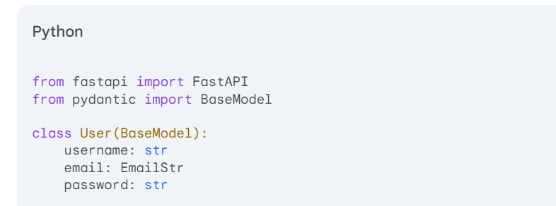

**Explanation:**

* This model defines a User class inheriting from BaseModel.
* It has three fields: username (string), email (validated email address), and password (string).

**Using Pydantic Models in Endpoints:**

1. **Endpoint Argument:** Include the Pydantic model class as the type annotation for the corresponding argument in your endpoint function.
2. **Automatic Parsing and Validation:** When a request arrives, FastAPI automatically parses the request body based on the model definition. It validates the data structure and types against the defined fields.

**Example (Registration Endpoint):**

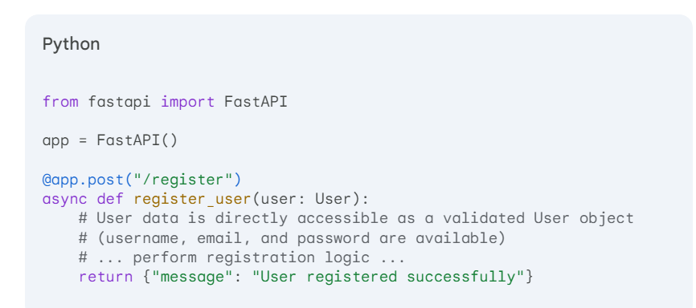

**Explanation:**

* The register_user endpoint takes a single argument user with the type User.
* When a POST request arrives at /register, FastAPI parses the request body according to the User model.
* If the data is valid (correct structure and types), the parsed user data is assigned to the user argument. This makes the data directly accessible within the endpoint function.
* If the data is invalid, FastAPI returns a 422 Unprocessable Entity error with details about the validation errors.

**Benefits of Pydantic:**

* **Data Integrity:** Pydantic enforces data structure and type constraints on request bodies, ensuring you receive the expected data format.
* **Automatic Type Conversion:** Pydantic automatically converts data types based on the field definitions, simplifying data handling.
* **Clear and Structured Data:** Pydantic models provide a well-defined structure for request data, making code more readable and maintainable.
* **Data Documentation:** Pydantic models serve as implicit documentation for your API endpoints, clearly communicating the expected request format.

**Defining Response Schemas:**

Pydantic models can also be used to define the structure of your API responses. By returning a Pydantic model instance from your endpoint function, you ensure a consistent and well-structured response format.

**Example (Registration Response):**

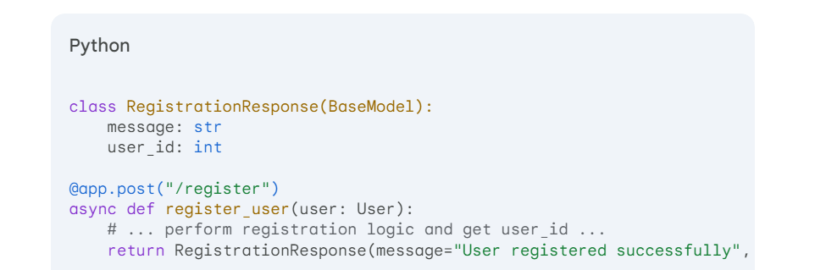

return RegistrationResponse(message="User registered successfully", user_id=user_id)

**FastAPI automatically serializes the Pydantic model instance into a JSON response for the client.**

**In conclusion, Pydantic models are an essential tool in FastAPI for automatic data validation, structured data handling, and clear API documentation. By leveraging Pydantic, you can build robust and user-friendly FastAPI applications.**

## OpenAPI documentation: FastAPI

FastAPI excels in simplifying API creation and integration by automatically generating OpenAPI documentation. This documentation, also known as Swagger, provides a clear and machine-readable specification of your API.

**Understanding OpenAPI:**

* OpenAPI is a widely adopted standard for describing RESTful APIs.
* It defines a format for documenting API endpoints, request structures, response schemas, and more.
* By adhering to OpenAPI, your API becomes easily discoverable and usable by developers and tools that understand the specification.

**FastAPI's Automatic Generation:**

* FastAPI automatically generates OpenAPI documentation based on your code.
* It analyzes your endpoint definitions, including:
  + HTTP methods (GET, POST, PUT, etc.)
  + Paths and path parameters
  + Request and response data structures (if you use Pydantic models)
* Based on this information, FastAPI constructs a comprehensive OpenAPI document.

**Accessing the Documentation:**

* By default, FastAPI serves the generated OpenAPI documentation at the /openapi.json URL path.
* You can access this URL using a web browser or any tool that understands OpenAPI to explore your API's details.

**Benefits of Automatic OpenAPI Docs:**

* **Reduced Documentation Effort:** You don't need to manually write extensive API documentation.
* **Improved Developer Experience:** Developers can easily understand your API's structure and usage from the OpenAPI specification.
* **Tool Integration:** Various tools and libraries can leverage the OpenAPI documentation for code generation, testing, and client development.

## Path and Query Params

FastAPI offers different ways to access path and query parameters in your endpoint functions. Here's a breakdown:

**Path Parameters:**

* Path parameters are defined directly within the route path enclosed in curly braces ({param_name}).
* They are extracted automatically from the URL path and made available as keyword arguments in your endpoint function.

**Example:**

from fastapi import FastAPI

app = FastAPI()

@app.get("/users/{user_id}")

async def get_user(user_id: int): # user_id is a path parameter

# Access user data based on user_id

return {"message": f"Retrieved user with ID: {user_id}"}

**Explanation:**

* The route path /users/{user_id} defines a path parameter named user_id.
* When a request arrives at /users/123, the get_user function is triggered.
* The extracted value 123 is automatically assigned to the user_id argument in the function.

**Query Parameters:**

* Query parameters are optional key-value pairs appended to the URL after a question mark (?).
* They are accessed using the request.query_params dictionary or the Query function from fastapi.

**Accessing with request.query_params:**

Python

from fastapi import FastAPI

app = FastAPI()

@app.get("/search")

async def search(query: str = None): # query is an optional query parameter

if query:

# Search for data based on the query parameter

return {"message": f"Search results for: {query}"}

else:

return {"message": "No search query provided"}

**Explanation:**

* The /search endpoint has an optional query parameter query with a default value of None.
* The request.query_params dictionary holds all query parameters as key-value pairs.
* We access the query parameter within the function and use it for searching.

**Accessing with Query function:**

Python

from fastapi import FastAPI, Query

app = FastAPI()

@app.get("/search")

async def search(query: str = Query(..., description="Search term", min_length=3)):

# Access query with validation and description

return {"message": f"Search results for: {query}"}

**Explanation:**

* The Query function provides a more structured way to access query parameters.
* We specify a default value (...), a description for documentation, and a minimum length validation.
* The query argument directly receives the validated value.

**Choosing the Approach:**

* Use path parameters when the parameter is essential for identifying a specific resource within the URL path (e.g., /users/{user_id}).
* Use query parameters for optional data that can be dynamically included with the request (e.g., /search?query=keyword).

**In summary, FastAPI offers clear and flexible ways to handle both path and query parameters in your endpoint functions, making it easy to access request data and build dynamic APIs.**

## Getting Started:

Here's a quick guide to get started with FastAPI's OpenAPI documentation:

1. **Create a FastAPI Application:** Install FastAPI (pip install fastapi) and create a basic application file.
2. **Define Endpoints:** Use decorators like @app.get, @app.post, etc. to define your API endpoints with their respective paths and HTTP methods.
3. **Leverage Pydantic Models:** Define Pydantic models for your request and response data structures. This provides additional clarity and validation in the OpenAPI documentation.
4. **Start the Application:** Run your FastAPI application using uvicorn main:app --reload (replace main with your application file name).
5. **Access the Documentation:** Open http://localhost:8000/openapi.json in your web browser or preferred OpenAPI viewer to see the generated documentation.

**Additional Tips:**

* **Customize Documentation:** While automatic generation is great, you can further customize the OpenAPI document using FastAPI's features like app.openapi_schema and app.docs_url.
* **Interactive Documentation:** FastAPI also supports integration with tools like Redoc or Swagger UI to provide an interactive user interface for your API documentation.
* **Explore FastAPI Documentation:** Refer to the FastAPI documentation for detailed explanations and customization options: <https://github.com/tiangolo/full-stack-fastapi-template>

By understanding and utilizing FastAPI's automatic OpenAPI documentation, you can streamline your API development process and create well-documented APIs that are easier for developers to integrate with.

## FACTS:

FastAPI, being a Python framework, doesn't directly map to the traditional layered architecture often used in Express.js (Node.js). However, FastAPI offers features that allow you to achieve similar modularity and separation of concerns. Here's a breakdown:

**Layered Architecture in Express.js:**

* **Routes and Middlewares:** Define URL paths and handle request processing logic before reaching controller functions.
* **Controllers:** Handle business logic specific to each API endpoint.
* **Services:** Encapsulate reusable functionalities like database interactions, authentication, etc.
* **Models:** Represent data structures used in the application.

**FastAPI's Approach:**

* **Dependency Injection:** FastAPI leverages dependency injection to inject dependencies like database connections or services into endpoint functions. This promotes loose coupling and modularity.
* **Asynchronous Functions:** FastAPI uses asynchronous functions for endpoint handlers, allowing for non-blocking operations and improved performance.
* **Pydantic Models:** Pydantic models serve as data structures and validation tools, similar to models in Express.js.

**While FastAPI doesn't have a strict layer separation, you can achieve similar structure using:**

1. **Dependency Injection:**

Python

from fastapi import FastAPI, Depends

# Service class for user management

class UserService:

def __init__(self, db):

self.db = db

async def create_user(self, user):

# Logic to create user in database using self.db

# Function to get a database connection

async def get_db():

# Code to connect to the database

return database_connection

app = FastAPI()

@app.post("/users")

async def create_user(user: User, service: UserService = Depends(UserService(Depends(get_db)))):

# User data is in the 'user' argument

# UserService instance with database connection is injected as 'service'

await service.create_user(user)

return {"message": "User created successfully"}

* Here, get_db provides the database connection, injected into the UserService constructor.
* The UserService instance is then injected into the create_user endpoint function.

1. **Asynchronous Functions:**

Python

from fastapi import FastAPI

app = FastAPI()

@app.get("/users")

async def get_users():

# Async code to fetch users from a database

return {"users": []}

* Asynchronous functions allow for non-blocking operations, improving performance.

1. **Pydantic Models:**

Python

from fastapi import FastAPI

from pydantic import BaseModel

class User(BaseModel):

username: str

email: str

* Define Pydantic models for data structures and validation.

**Benefits of FastAPI's approach:**

* **Clean and Concise Code:** Endpoint logic stays focused on the specific task.
* **Dependency Management:** Loose coupling and easier testing through dependency injection.
* **Improved Performance:** Asynchronous functions enable non-blocking operations.

**While a strict layered architecture might not be directly achievable in FastAPI, these techniques promote modularity, code reusability, and maintainability in your FastAPI applications.**

## Best Practices:

Best practices for developing FastAPI applications, incorporating insights from expert ratings:

**RESTful API Design Principles:**

* **Resource-Based Design:**
  + **Resources:** Represent data entities (users, products, orders, etc.).
  + **Endpoints:** Map to URLs and actions on resources (e.g., /users, /products/{id}).
  + **HTTP Methods:** Utilize HTTP methods for CRUD operations:
    - GET: Retrieve resources
    - POST: Create new resources
    - PUT: Update entire resources
    - PATCH: Partially update resources
    - DELETE: Delete resources

**FastAPI Implementation:**

* **Path Operations:** Use FastAPI's decorators (@app.get, @app.post) to define endpoints with HTTP methods and paths.
* **Path Parameters:** Capture dynamic URL segments (e.g., /users/{id}).
* **Request Body:** Access incoming data (POST, PUT, PATCH) using request.body.

**Data Serialization and Deserialization:**

* **JSON:** Prefer JSON for request and response bodies due to its widespread use.
* **Pydantic Models:** Define data models with Pydantic for validation, type hints, and automatic documentation.
* **FastAPI Serializers:** Leverage FastAPI's built-in JSON handling to convert Pydantic models to JSON and vice versa.

**Code Structure and Maintainability:**

* **Separation of Concerns:** Separate data models from logic for clarity and reusability.
* **Business Logic:** Implement business logic in separate functions or classes.
* **Dependency Injection:** Use dependency injection (DI) with tools like DependencyInjector for cleaner dependency management and testability.

**Testing:**

* **Unit Tests:** Write unit tests to verify the functionality of individual functions and modules.
* **Integration Tests:** Test how different parts of your API interact with each other.
* **Consider using pytest** for its flexibility and rich ecosystem of testing tools.

**Documentation:**

* **Automatic Documentation:** Leverage FastAPI's built-in OpenAPI (Swagger) documentation generation.
* **Swagger UI:** Integrate with tools like Swagger UI to provide a user-friendly interface for exploring your API.

**Additional Best Practices:**

* **Error Handling:** Implement robust error handling with custom exception classes and informative error responses.
* **Authentication and Authorization:** Secure your API using authentication mechanisms like JWT or OAuth2 to control access.
* **Asynchronous Programming:** Embrace async/await for improved performance, especially when handling I/O-bound tasks (e.g., database calls).
* **Logging:** Employ a logging library to record API activity and aid in debugging and troubleshooting.
* **FastAPI Security:** Explore FastAPI's built-in security features like CSRF protection and cookie handling.
* **API Rate Limiting:** Implement rate limiting to prevent abuse and protect your API resources.
* **Monitoring and Observability:** Use tools like Prometheus or Grafana to monitor API performance and health.
* **Code Formatting and Linting:** Enforce consistent code style with tools like Black and autoflake.
* **Version Control:** Use Git for version control and collaboration.

By following these guidelines, you'll create well-structured, maintainable, efficient, and secure FastAPI applications ready for production use.